Extensible Protocol and Development Load Testing Suite

**Abstract**

Extensible, multi-threaded, simple to interface with load testers are a very rare occurrence in enterprise. This report establishes the field and what features and requirements should be expected at a minimum by a user. After establishing that a ticket-based development methodology will be used during development to keep different components on task and developed. Major components and their designs are then discussed in detail including any issues that cropped up during those designs. The implementation “log” discusses what components were developed and any pitfalls or challenges that were observed during their development finally discussing issues with poorly thought out classes causing issues with proper unit testing. The acceptance testing shows that many features are still outstanding, and some glaring bugs are present in the more “outward” facing areas of the program. However, it is ultimately shown that the claim originally made is possible and viable as a full software solution. With hardware applications and helper libraries for protocol design stated as possible future enhancements.

Contents

1 Introduction 4

2 Research 4

3 Requirements & Acceptance Tests 11

3.1 User Stories 11

3.2 Requirements 12

3.3 Acceptance Tests 15

4 Methodology 17

4.1 Development Methodology 17

4.2 Timeline 18

5 Designs 19

5.1 What runs where and how (threads/tasks) 19

5.2 Logger 20

5.3 Thread Pool Queue 20

5.4 Test Case Analyser 21

5.5 Database 22

5.6 Test Handler 22

6 Implementation 23

6.1 Log 23

6.1.1 Setting Up Gtest/Gmock 23

6.1.2 Project Structure 23

6.1.3 Moving from Raw Pointers to Special Pointers 24

6.1.4 Generic Thread Pool 24

6.1.5 Network Communication 25

6.1.6 Logger and testing 25

6.1.7 Plugin Architecture 26

6.1.8 Parsing Complications 27

6.1.9 Running a Test 28

6.1.10 First Run 28

6.1.11 API 29

6.1.12 Final unit tests 29

6.2 Testing 30

6.2.1 Unit Tests 30

6.2.2 Acceptance Tests 31

7 Evaluation 34

7.1 What is Still Outstanding 34

7.2 What Has Been Shown 34

8 Conclusion 35

8.1 Future Enhancements 35

8.2 Into the Future 35

9 References 36

10 Table of Figures 38

11 Table of Tables 38

12 Appendix 38

12.1 Appendix-1 38

12.2 Appendix-2 49

12.3 Appendix-3 52

# **Introduction**

IP traffic simulators with more realistic flow and simpler interface than currently used systems that also offer multi-threading as a standard for increased flow and more multi-tasking. In addition to this, a program that will support whatever protocol the developers wish to test against using a plugin system. This is important as the current software out there does not have particularly configurable flow, have complex interfaces, cannot be automated or have a very small subset of protocols with which they can work. Regarding content of the project, any licensing issues will be avoided by using as few third-party libraries as possible; the ones that are used will be under FOSS licensing. Ethically, the project could help to trivialise Denial-Of-Services attacks by providing a platform by which unsavoury people could launch high traffic attacks against networks; even using the victim’s preferred protocol to communicate and using the software to change and rotate the requests to help mask what they are doing.

# Research

Simulating the internet proper is near impossible, due to its sheer scale, impracticality and the number of nodes needed (Sumeet Kumar and Kathleen 2017). But it is certainly possible to create software that facilitates the entire load testing process (Yan et al., 2014). It helps developers to understand their application in extreme circumstances (PR Newswire Association LLC, 2014).

Simulation has played a vital role in system verification for a long time; however, it requires a great deal of time and resources. But its usefulness and importance in software engineering has been noted in detail by many authors (Sun & Männistö, 2012). Test tools can be considered an addendum to normal development and perform a task related to but separate to direct development (Na and Huaichang, 2015). Load testing is vital to proving that web services (and other load-based systems) meet the demands of its users, both in traffic and behaviour (Draheim et al., 2006), and is as important to the testing of an application as unit testing and integration testing (Jiand & Hassan, 2015). It can help to locate issues in the code that might not appear under smaller load. These errors are called “Load sensitive”. The rate at which transactions are conducted constitutes load. Workload (described by characteristics and intensity), environment and, high-level metrics all define a load test and its results intensity refers to arrival rate and throughput of data (Malik, 2010). Sending this to a target for test purposes, constitutes a Load Test (Jiang, 2015).

Stress testing is similar to workload, however the express intention is to break the system, and to verify how it recovers (Bayan and Cangussu, 2006)(Jiand & Hassan, 2015). All of these come together in a test report (Malik, 2010).

Load testing is performed in some degree on implemented systems as opposed to the design or architecture of the system in question (Jiand & Hassan, 2015). The purpose of a load test is to help guarantee if a given system's performance is acceptable under peak conditions. This means checking response times and resource usage and helping developers, testers, managers and potential customers decide whether the system's performance is acceptable or more work needs to be done to bring it to within acceptable limits. While all this happens there are still any other factors to consider (Zhang et al., 2011).

As focus shifts towards offering software as a service with offsite hosting (a.k.a. “The Cloud”), and datacentres, more and more emphasis must be put on testing these systems that require incredible high throughputs due to the sheer number of people accessing them and the complex actions that they perform. However, this also extends to making sure that a load tester can be provided/offered as-a-service (aaS) (Shojaee et al., 2015). Even classic server arrangements require load testing to some degree to guarantee their service is robust and reliable (Cico & Dika, 2014).

Mercury Interactive's LoadRunner was once the load testing market leader (Draheim et al., 2006). DITG, Harpoon, fudp, 2Hping, LoadUI, ApacheJmeter, and, curlLoader are currently available open source traffic generators, curlLoader has been noted for its flexibility (Bhatia et al., 2014) (Yan et al., 2014). Testmaker is another WS load tester that allows concurrency testing on Amazon EC2 and joins the open source load testers along with SoapUI and SOATest (The latter being noted for its growing popularity) (Grehan, 2005) (Yan et al., 2014) (Shojaee et al., 2015).

IBM Rational Performance Tester, SURGE and AlertSite (Hasenleithner and Ziegler, 2003) (Yan et al., 2014) are some closed source alternatives with proper support systems in place, AertSite even offers aftercare support to better help businesses understand and solve issues brought up from load testing.

Yet another tool, Iometer, can be used to gauge hardware usage and test performance of storage systems without complicated testbeds (Baltazar, 1998), which provides some direct insight into the hardware side of load testing.

Tests often need to be parameterised and modified, this can often be quite hard to do and means more advanced tools are needed (Draheim et al., 2006). Load test analysis methodology has been performed before (Malik, 2010) and it’s been shown that models can even be computer generated based on behaviour observation (Bayan and Cangussu, 2006).

Current tools support simple test cases with a fixed sequence of actions (Draheim et al., 2006) with a limited number of scenarios (Bhatia et al., 2014)

As software shifts towards being offered “as-a-service” (-aas or Xaas). Offering some sort of load tester as a service would be wise and allow for future proofing. A Load tester will likely contain four major components: Test Receiver, Test Manager, Middleware Manager and a Test Runner:

* Test Receiver: Receives tests to run from the tester, can also monitor tests
* Test Manager: Manages queues of tests and dispatches them, gathering and merging test results
* Test Runner: Invokes the tests. Analyses validity of results
* Middleware Manager: provides and manages test runners for use within the system

(Yan et al., 2014)

Giving the user the option of adjusting the size and rate of sending is beneficial. Existing approaches consist of increasing the query size, number of queries or, the rate at which queries are made (Zhang et al., 2011). XML is also already used by large swathes of developers and engineers including many protocols themselves (Garg and Lavahte, 2017). JSON is not as widely supported regarding protocols and can fall over when it encounters special characters (however this is purely implementation dependent).

Some solutions do not provide workflow testing or even true load testing. They can also make documentation more difficult (Garg and Lavahte, 2017). Cross-platform running would be a boon to making sure that the most amount of people possible are reached (Garg and Lavahte, 2017).

Other software already offers a great deal of different testing approaches and services for maximum beneficial interaction (Garg and Lavahte, 2017). Allowing for scripting support of any kind would be very beneficial in making sure that the process can be automated with minimal user interaction and to better fit into an AGILE work flow (Shojaee et al., 2015). There are several limitations to load testing currently: Cost-effectiveness, increasing input size may be very costly and could force the system to continually perform the same computation (Zhang et al., 2011).

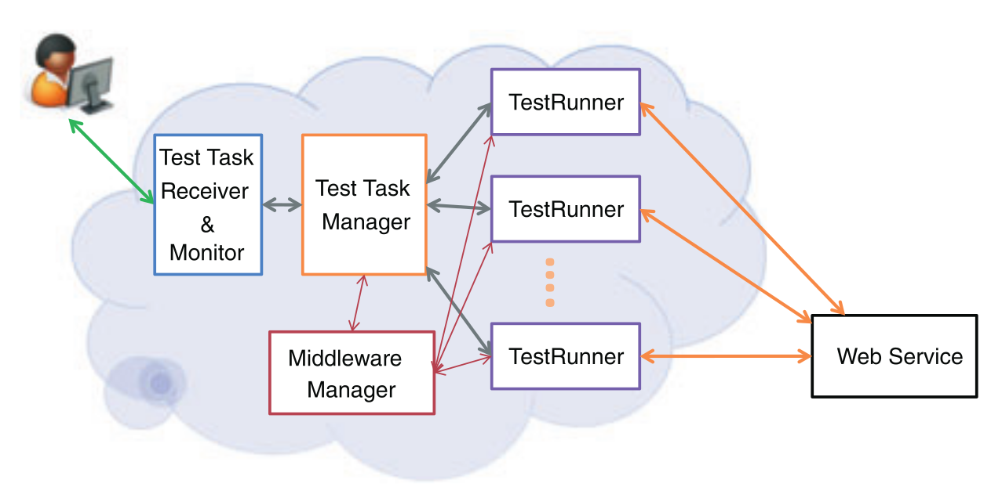

Figure : Theoretical layout of a web-service (Draheima and Weber, 2005)

Artificial traffic generation is often the only practical way to really verify the running of a service. Hardware traffic generation often leads to greater packet drop at the target, but it is faster than a software solution however, it also comes at a greater cost. Also, generating precise traffic allows much greater control (Bhatia et al., 2014).

Load testing should be performed regularly to make sure that resources are correctly provisioned (Draheim et al., 2006). Different Modes need to be offered for proper testing; Static, step and maximal testing are three such modes. Static runs for a specific load. Step runs for measuring usability under a load span. Maximal load to determine upper limits (Yan et al., 2014). Load testing can turn up a variety of problems including: memory leaks, error keywords, deadlocks, unhealthy system states and throughput problems (Jiand & Hassan, 2015).

Testing must be performed even on the smallest servers and services. Without testing significant amounts of resources could be lost to minor bugs cropping up and taking out the entire system when they could have been found during a simple load testing phase during development/setup (Koh et al., 2018). Large scale systems especially so must be tested to make sure that they can still service the millions of simultaneous requests every second (Jiang, 2015). As the demand on servers increase, and as more things become cloud based, it will be become increasingly vital to test these systems to verify they still maintain maximum throughput. Especially as users attempt to store and access files on these services (Baltazar, 1998).

Load testing works best with lots of different entities fully flexing a system (Chapuis & Garbinato, 2017). AGILE development works best with higher amounts of automation and as deterministic results as possible (Garg and Lavahte, 2017). However different runs of the same test may produce different results anyway (non-deterministic) so it would be good to limit these situations as much as possible (Hwang et al., 2004). No matter the system being tested a “client/server” model will be used for all interactions (Hwang et al., 2004).

Manually testing web services would be incredibly laborious, slow and expensive (Garg and Lavahte, 2017). Real user data can (and should) be used to model traffic. However, such models are less versatile than stochastic ones. Script driven approaches are common; visual editors massively increase usability (Draheim et al., 2006).

Reconfigurability for a variety of different connections for different purposes and clients and tests. Low cost, low resource would be a significant boon, however using the resources as efficiently as possible is key. Traffic load co-ordination would also help to improve results and efficiency with traffic aggregation to make sure all traffic acts on a single interface at the target. Being able to monitor the traffic is also a good feature to have (Bhatia et al., 2014).

Another structure would involve: Input identification, controller tuning and a controller. Input Identification involves finding inputs that affect the resource of interest. Controller tuning involves figuring out the internal parameters of the chosen controller. The controller itself drives the testcases to what load level is wanted. (Bayan and Cangussu, 2006).

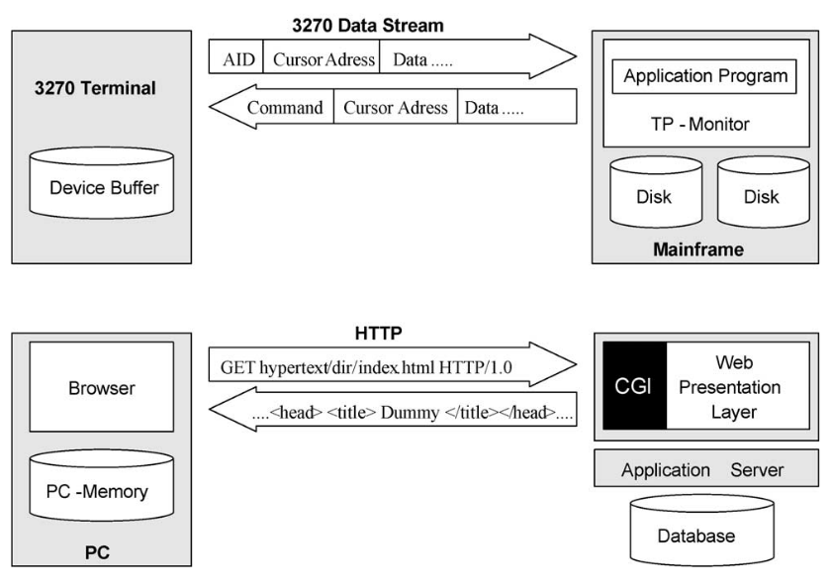

Figure : Examples of ultra-thin client based submit/response style systems (Draheima and Weber, 2005).

Pseudo random generators are potentially very good for the purposes of this program (Akhshani et al., 2017). While on one hand we need different tests to be identical every run to guarantee that the tests are valid, it can offer some more specialised testing for tests that might run for an entire day, possibly detecting memory leaks and other load sensitive bugs that might only appear under such conditions. The algorithm for constructing a random number generator based on quantum chaotic maps can also be used to create a good chaos model from which to work. Only using user activity graphs instead, to better try to model peak times. (Akhshani et al., 2017) User interaction can be modelled as a bipartite state transition diagram (Draheim et al., 2006).

Geographically distributed instances would improve the results per test task. Large amounts of concurrency within each instance would be good as the loads can be very large, and the traffic could be very high (Yan et al., 2014).

Even though the systems themselves would need testing; load testing from a cloud-based platform would be entirely possible (and preferable in some situations where location of requests is important) (Shojaee et al., 2015). Large amounts of concurrency within each instance would be good as the loads can be very large, and the traffic could be very high (Yan et al., 2014). Being able to scale to simulate potentially millions of requests would be incredibly beneficial to the testing of the software (Jiand & Hassan, 2015).

It is important that the user designs loads well, but more importantly that the software interprets them accurately, this is also a practice left up to the user in creating the plugin (Jiand & Hassan, 2015), however the tests must be interpreted and returned accurately for reading.

Current load testers have a very limited number of virtual users and testing different configurations is difficult and time-consuming. Having the ability to scale the software up depending on the users' needs would be highly desirable (Shojaee et al., 2015).

Making sure messages are routed to the correct threads while the system is running is very important as messages can be interleaved by the underlying asynchronous operations (Koh et al., 2018). Making sure that the software can run on a variety of system's will help to maximise its customer base. This can best be achieved by making sure that only the standard libraries are adhered to mostly (Baltazar, 1998).

There will be three steps to load testing for the user when it comes to using the software after the plugins have been created: designing it, executing it and, analysing the results (Jiang, 2015). Anomalies should be able to be detected by analysis of the performance metrics and execution logs (Jiand & Hassan, 2015).

Having a variety of ways to check on and use the software would be very useful. This can include a full UI, A task monitor, and a configuration manager. An API for interaction would also be very useful as it would allow different ways of interacting with the system for different purposes. Being able to extend the program beyond its basic function would be an incredibly useful feature and is already in place in many modern systems such as Robot (Na and Huaichang, 2015).

Other great features to have that are present in other systems are custom load testing “Scripts”, specific agents, environment switching, test debugging and performance monitoring. Maximising what tools, it can integrate would be a great help to supporting the AGILE workflow too, with integration with systems such as Maven, Hudson, Navigator, Junit, ApacheAnt (Garg and Lavahte, 2017).

# Requirements & Acceptance Tests

## User Stories

The requirements were generated by developing "user stories”. Each user story corresponds to an action or task that the *user* of the system wishes to carry out. The user stories are organised under “epics” which dictate more generic ideas and they, themselves, are organised under “Themes” which define each high-level component of the program. Some examples of these are given below. For the rest of the user stories they are all given in **APPENDIX-1.**

Themes

|  |  |
| --- | --- |
| ***THEME 6*** | |
| *I need a* | Test Runner |
| *For* | Running testcases |

THEME 6 Epics (Test Runner)

|  |  |
| --- | --- |
| ***EPIC 6.1*** | |
| *The* | Test Runner |
| *Needs to* | Send data to a target |

|  |  |
| --- | --- |
| ***EPIC 6.2*** | |
| *The* | Test Runner |
| *Needs to* | Receive Data from a target |

Theme 6, Epic 1

|  |  |
| --- | --- |
| ***USER STORY 6.1.1*** | |
| *As a* | Tester |
| *I want to* | Send data to a target |
| *So that I can* | Measure it’s load or test a protocol |

Theme 6, Epic 2

|  |  |
| --- | --- |
| ***USER STORY 6.2.1*** | |
| *As a* | Tester |
| *I want to* | Have the data results recorded |
| *So that I can* | Verify everything is working |

Theme 6, Epic 3

|  |  |
| --- | --- |
| ***USER STORY 6.3.1*** | |
| *As a* | Tester |
| *I want to* | Have the test runner configure itself automatically |
| *So that I can* | Make less API calls |

|  |  |
| --- | --- |
| ***USER STORY 6.3.2*** | |
| *As a* | Tester |
| *I want to* | Select the branching method |
| *So that I can* | Configure the software based on present resources |

|  |  |
| --- | --- |
| ***USER STORY 6.3.3*** | |
| *As a* | Tester |
| *I want to* | Know the test runner will read what protocol it needs |
| *So that I can* | Make less API calls |

|  |  |
| --- | --- |
| ***USER STORY 6.3.4*** | |
| *As a* | Tester |
| *I want to* | Know the test runner will read what Comms handler it needs |
| *So that I can* | Make less API calls |

## Requirements

Below are the requirements that have been generated using the above user stories and any other features that would be nice-to-have gained from the original research. The original ‘requirements’ list (mapping the user stories to Acceptance Tests) is given as **APPENDIX-2.**

**Key: S = The Highest Priority, A, B, C, D = the Lowest Priority**  
*The last column states whether the requirement is functional or non-functional (N = non-functional)*

Table Requirements List

|  |  |  |  |  |  |  |
| --- | --- | --- | --- | --- | --- | --- |
| **#** | **Description** | **Priority** | **Data Created** | **Source** | **Acceptance Tests** | **F** |
| **1** | The software can dynamically load protocol plugins | S | 31/30/2019 | Research | PD_1, PD_13 | F |
| **2** | The software can dynamically load communication plugins | S | 31/30/2019 | Research | PD_2, PD_13 | F |
| **3** | Threads per testcase can be configured | S | 31/30/2019 | User Stores | PD_3 | F |
| **4** | Configure hard limit for number of threads | S | 31/30/2019 | User Stories | PD_4 | F |
| **5** | Can be run as a service | A | 31/30/2019 | User Stories | PD_5, PD_7, PD_8 | F |
| **6** | Be easily maintainable | S | 31/30/2019 | User Stores | PD_6 | N |
| **7** | Be able to start tests | S | 31/30/2019 | User Stories | PD_9 | F |
| **8** | Be able to stop tests | S | 31/30/2019 | User Stories | PD_10 | F |
| **9** | Be able to query running tests | A | 31/30/2019 | User Stories | PD_5, PD_17, PD_18, PD_19, PD_30 | F |
| **10** | Be able to query program running stats | B | 31/30/2019 | User Stores | PD_5, PD_11, PD_19 | F |
| **11** | Easy to use API | B | 31/30/2019 | User Stories | PD_9, PD_12 | N |
| **12** | Can be interacted with without interfering with a test/normal running | A | 31/30/2019 | User Stories | PD_5 | F |
| **13** | Program can be killed/has a kill switch | C | 31/30/2019 | User Stories | PD_16 | F |
| **14** | Easy to setup software | C | 31/30/2019 | User Stories | PD_14 | N |
| **15** | Easy to uninstall/remove software | C | 31/30/2019 | User Stories | PD_15 | N |
| **16** | Accessible API | B | 31/30/2019 | User Stories | PD_12 | N |
| **17** | Can read in XML testcases | S | 31/30/2019 | User Stories | PD_9, PD_13 | F |
| **18** | Can report errors in the testcase | B | 31/30/2019 | User Stories | PD_20 | N |
| **19** | Testcases can configure thread number | A | 31/30/2019 | User Stories | PD_21, PD_22 | F |
| **20** | Testcases can configure protocol | A | 31/30/2019 | User Stories | PD_23, PD_24 | F |
| **21** | Testcases can configure communication handler | A | 31/30/2019 | User Stories | PD_38 | F |
| **22** | Testcases can configure traffic rate | A | 31/30/2019 | User Stories | PD_25 | F |
| **23** | Testcases can configure chaos | A | 31/30/2019 | User Stories | PD_26, PD_27 | F |
| **24** | Can send data to a target | S | 31/30/2019 | Research | PD_9, PD_28 | F |
| **25** | Testcases can configure branching method | B | 31/30/2019 | User Stories | PD_39 | F |
| **26** | Can log goings on to a file | S | 31/30/2019 | User Stories | PD_31 | F |
| **27** | Logger must not affect system running to any great extent | A | 31/30/2019 | User Stories | PD_32 | N |
| **28** | Can write to a database | B | 31/30/2019 | User Stories | PD_29, PD_33, PD_34 | F |
| **29** | Can read from a database | B | 31/30/2019 | User Stories | PD_33, PD_34 | F |
| **30** | Can compare previous runs | B | 31/30/2019 | User Stories | PD_33 | N |
| **31** | Is geographically redundant | B | 31/30/2019 | Research | PD_35 | N |
| **32** | Can work together with other instances to perform tests | B | 31/30/2019 | Research | PD_35, PD_36 | F |
| **33** | Can access data on other instances from any instance | B | 31/30/2019 | Research | PD_36, PD_37 | N |

## Acceptance Tests

The acceptance tests will form a basis for deciding whether the software project meets its minimum criteria for its intended function or purpose. An example of some these are given below. The rest can be viewed in **APPENDIX-3.**

**Test Name**: PD_1  
**Requirement(s) Tested**: 1  
**Outline**: Load a Protocol plugin  
**Pre-requisites**: Service is running, a protocol plugin is available for loading, CLI open  
**Method**:

|  |  |  |
| --- | --- | --- |
| ***STEP*** | *Action* | *Expected Observation* |
| *1* | Enter command to load protocol plugin | Service accepts command without issue |

**Test Name**: PD_2  
**Requirement(s) Tested**: 2  
**Outline**: Load a communication plugin  
**Pre-requisites**: Service is running, a communication plugin is available for loading, CLI open  
**Method**:

|  |  |  |
| --- | --- | --- |
| ***STEP*** | *Action* | *Expected Observation* |
| *1* | Enter command to load communication plugin | Service accepts command without issue |

**Test Name**: PD_3  
**Requirement(s) Tested**: 3  
**Outline**: Program reads the maximum threads from the testcase file  
**Pre-requisites**: Service is running, a testcase is ready to read, CLI open  
**Method**:

|  |  |  |
| --- | --- | --- |
| ***STEP*** | *Action* | *Expected Observation* |
| *1* | Enter command to load a test | Service accepts command without issue |
| *2* | Read log | Log shows that maximum threads has been set |

# Methodology

## Development Methodology

Due to the nature of the project traditional/team-based methodologies may not be totally appropriate, or there may even be methodologies that can be used specifically *for* solo teams (Pagotto et al., 2016). However, it has been suggested that using older, more standard, methodologies are bestwith only minor changes.

Initially the plan for development was to follow an *iterative* model after the initial libraries had been identified. As each library is discovered to be a requirement it is to be designed, implemented and then tested. Testing is to take on a Test-Driven-Development approach, code is written *exclusively* to make the unit tests pass.

However, an iterative model does not lend itself to management and organisation by design. As such using a stricter (and specific) AGILE methodology would make a great deal more sense as it does help to make sure that teams (or solo developers) can self-organise better and more importantly can adapt better to any changes in design or requirements that may come up at a later date. The two methodologies under consideration are SCRUM and Kanban.

SCRUM methodology decides the work-flow of a cross-functional, self-organising team to perform all steps (designing, building and testing) of the development at once all the time. This is done by completing prioritised tasks pulled from a “product backlog” that describes all required tasks to complete the project. The tasks are pulled into a sprint (“time boxed iteration”) backlog and completed by the team over the course of a sprint (typically a 2 to 4-week development-cycle). At the end of the sprint the team is to evaluate how they did and how many (and what) tasks are to be pulled into the new sprint backlog. This process is typically managed by an honorific “SCRUM Master” that will often change sprint to sprint. Daily stand-ups are a mandatory part of SCRUM (Rubin, 2013).

Kanban Functions similarly to scrum however it does not have a concept of Sprints. Instead, tasks are completed in a LEAN/ “just-in-time” fashion. As one “channel” (the vertical component to a Kanban board) fills up the previous task cannot continue. A channel can only contain so many tasks. If a new task is wanted in the channel, then some tasks must be cleared. This gives a constant push through on the system that pulls more and more tasks and forces other tasks to be completed, instead of their priority simply being demoted. Tasks are still completed with a priority fashion, however they must ALL be finished (Ahmad et al., 2018).

Scrum is geared towards having meetings with the team and making sure each other know exactly where everyone stands to make sure nothing is blocked by some other task. Kanban will serve as a great way to make sure tasks are not put off until later “sprints”. As a solo team, there is no need to be quite that organised. Completing tasks “just-in-time” will mean a need for less second opinions and more just performing.

For that reason, Kanban will be the methodology that will be followed for this project.

## Timeline

Table : Timeline

|  |  |  |  |  |  |  |  |  |  |  |  |  |  |  |
| --- | --- | --- | --- | --- | --- | --- | --- | --- | --- | --- | --- | --- | --- | --- |
| Item | Mar | Apr | May | Jun | Jul | Aug | Sep | Oct | Nov | Dec | Jan | Feb | Mar | Apr |
| Research |  |  |  |  |  |  |  |  |  |  |  |  |  |  |
| Requires |  |  |  |  |  |  |  |  |  |  |  |  |  |  |
| Design |  |  |  |  |  |  |  |  |  |  |  |  |  |  |
| Setup |  |  |  |  |  |  |  |  |  |  |  |  |  |  |
| Implements |  |  |  |  |  |  |  |  |  |  |  |  |  |  |
| Testing |  |  |  |  |  |  |  |  |  |  |  |  |  |  |
| Final Bits |  |  |  |  |  |  |  |  |  |  |  |  |  |  |

The timeline given above will serve as a rough guideline for when each area of my project will take place. Requirements development will take place during the active research component as many of them will come from the research itself (and the generation of user stories, which themselves will come from the research). Design cannot take place before the requirements are finished, ideally. However, during the design the development environment can begin to be setup, along with any miniscule spikes and first-hand research to test various aspects of the software requirements and the possibility that they will work.

Implementation will take the longest as when more of the program has been completed the tests will begin to take the form of specific unit-tests and overall system/module tests. The timeline also allows for issues to crop up and hopefully be handled in time, as opposed to any issue potentially pushing the schedule back too far and causing a severely late project.

As testing ends an important task is making sure the code-base is sound and up-to standard. Along with full comments and documentation. It is also important that it does what it has set out to do. This period also allows for the final touches to this document and any other sundries that may need to take place.

# Designs

## What runs where and how (threads/tasks)

After deciding that it should run as a daemon, the next step was to Figure out the best way of handling commands and state changes. Along with making sure that data can be passed between all relevant points of the program to where it is needed.

The original ACP diagram to model each concurrently running thread had to be updated to A) use the ACP diagram correctly, B) reflect newly gained knowledge regarding the API and, C) a change of opinion in how the program should be interfaced with.

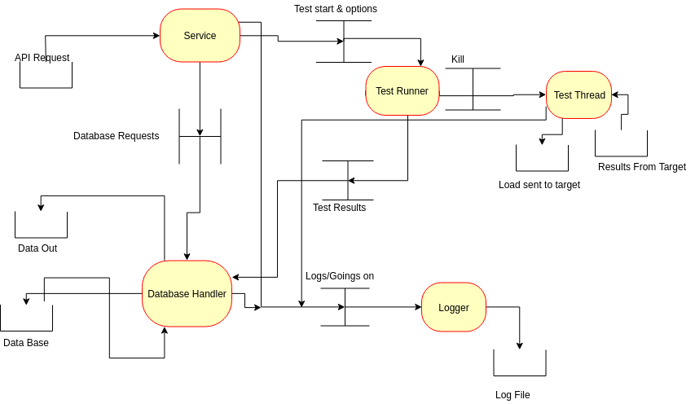

Figure : ACP Diagram

## Logger

The most important thing the logger needs to do is to A) log things and to B) not slow down the program. To this end it was decided that the logger should run as a separate task. With each component only writing to a log message queue that is then gradually flushed to the file itself.

This method should help in making sure that the program does not end up bogged down in writing to the disk (a much slower task than simply using CPU). Though, processes dealing with disk writes are prioritised over processes vying for CPU usage.

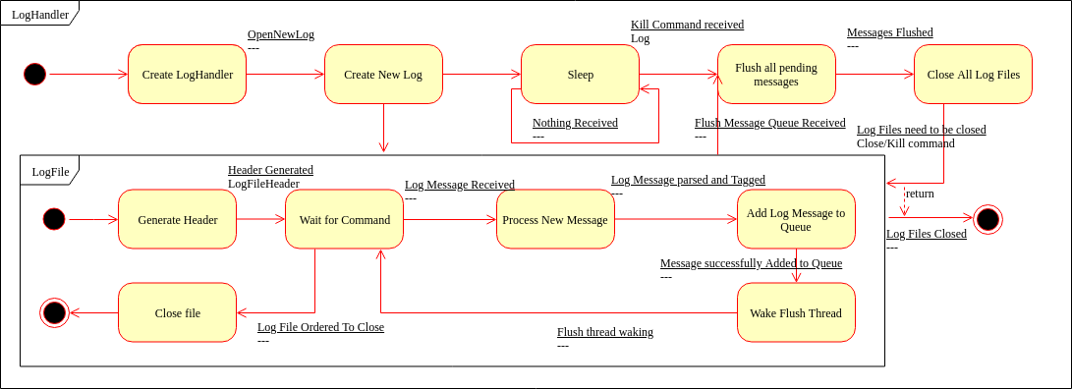

Figure : Log and Log Handler Diagram

## Thread Pool Queue

When this project was first started the initial plan was to have threads spawn wherever they were required (with no attention being paid to tracking them, other than in the instances that they existed). After some research and advice, the “Thread Pool Queue Pattern” (TPQ) was discovered. This allowed the software to have a central thread handler that simply dished out work to threads as they were required. The threads being put to sleep upon a job being completed.

Another very important component of the TPQ was that it needed to be totally agnostic to the work it was doing to cut down on maintenance; so that a separate thread spawner wasn’t needed for every possible method/task that it would be.

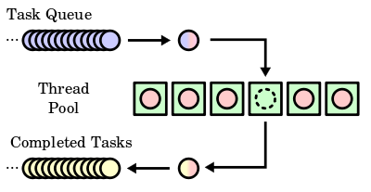

Figure Thread Pool Queue Diagram from Wikipedia

## Test Case Analyser

The test case analyser is one of the most important parts of the system. To that end making sure that its design is clear, robust and totally thorough is vital. Testcases will be written in a “human-readable format”; in this case XML. That means a parser/lexer will be needed so that the testcase can be turned into something the program itself can understand.

Once the document is parsed, its data needs to be stored in some way that can easily be accessed by the plugin and the other parts of the program that might require it.

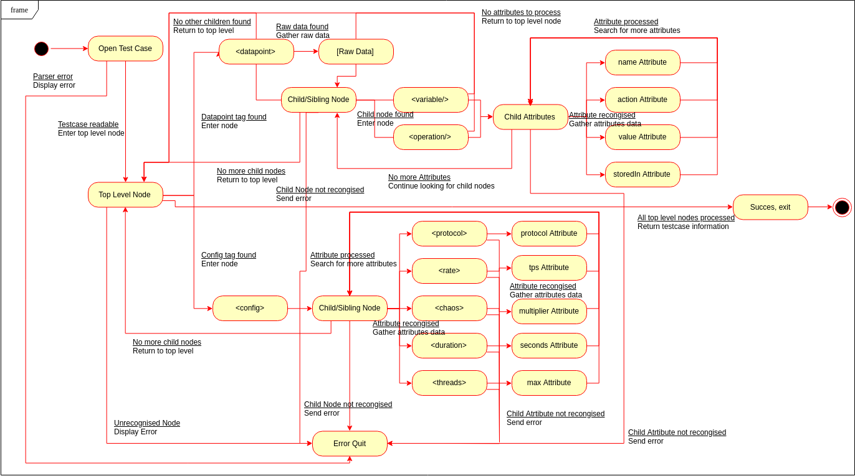

Figure : Testcase Parser State Machine

## Database

The database needs some sort of design, even if it will not be implemented. An Entity Relationship Diagram (ERD) was created to model what the database would/should like if it were to be created.

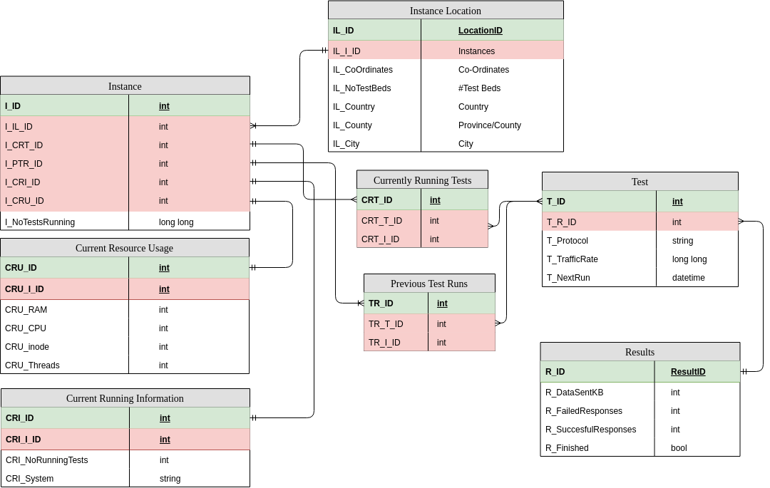

Figure : ERC Diagram

## Test Handler

Designing the test handler became a problem. One way would be to use the thread handler that had been so carefully created earlier in the project, as this would allow total control over the number of threads spawned. Using a thread branching method such as OpenMP would also be a very good way of performing this task. However, a third and potentially better way presented itself, especially regarding performance and maximum load testing: using a homogenous thread system (such as Open MPI).

Having at least 3 avenues to pursue means either more thought needs to be put into how the software should behave *or* the branching method can be created as a plugin, extending the usability and configurability even farther. And whilst the specifics of this is very much an implementation detail, abstracting everything *out* to allow the functionality to be switched will be an important design detail.

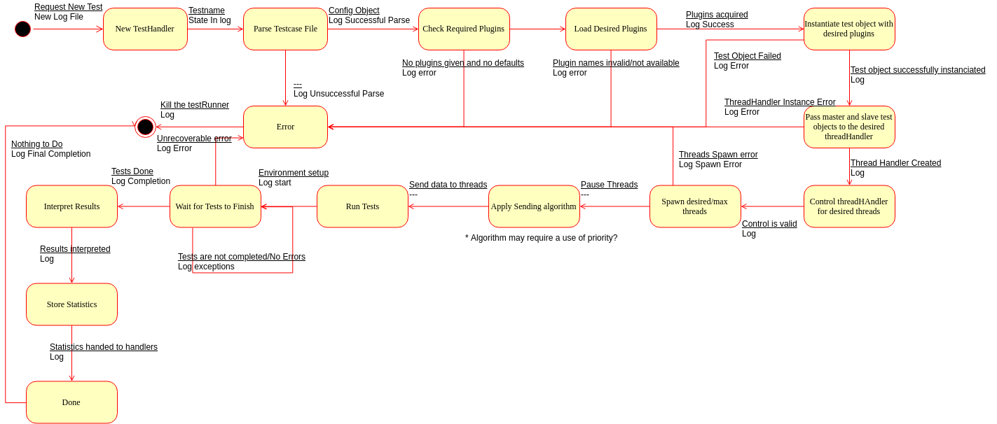

Figure : Test Runner State Machine

# Implementation

## Log

### Setting Up Gtest/Gmock

As soon as the project was started, it was decided that unit tests were a necessity. It would help in tracking down problems now, and it meant that small errors were corrected as soon as the library was built, not when the entire system fails and there’s no way to find out where.

After experimenting with building cppunit and Boost.Test, it was realised that mocking would also be a very useful tool to have, and neither of those projects supported it out-of-the-box. Eventually GoogleTest and GoogleMock were settled upon.

This made testing a great deal easier as it meant that there was a large user base and a strong customer base behind it. It also meant the unit test and mocking capabilities were built “into” each other and making sure the test and mocking frameworks worked together comfortably (and uniformly across files).

The GitHub project also provided some CMake targets that automatically downloaded, built, and linked them with the unit tests. Meaning that the dependency was self-resolving (requiring the more prudent users, who wish to compile the unit tests, need only an internet connection).

### Project Structure

Originally, the project structure was very flat. The top-level directory contained a single CMakeLists.txt and the main.cpp (for ProtDev itself). With each library/component of the program in a folder in there. Eventually the structure currently in use was discussed on a blog post from a Dutch developer, rix0r. Instead of every single package needing to be referenced in the top-level CMakeLists.txt Every single library is its own self-contained project that is exported to the larger CMake project. It also allows for more implementation hiding between libraries. And it helps to keep all executable files much tidier (along with executable targets being a great deal simpler to define).

### Moving from Raw Pointers to Special Pointers

A new feature of C++11 and up is the addition of *special pointers*. These special pointers are reference counted (thus are deleted automatically when nothing is referencing them) and allow finer control over how they should behave as “pointers”. When it was realised that modern C++ advocates *against* the use of traditional raw pointers, it was set about updating what had been written to conform to the current standard.

### Generic Thread Pool

The most significant feature of ProtDev is its ability to handle multiple threads sending data to a target. For increased control and higher bandwidth generally. The original plan was to have threads handled on an as-required process. Whatever object required them would just be handed one. After some more deliberation, discussion and research, the TPQ pattern was discovered and implemented.

This method allowed the maximum number of threads to be limited from a central area. However, a TPQ for every possible return type a thread may have would have to be created. One method would be to just do that and create a new handler for each return type. Another would be to do away with type safety and use a void* return type.

C++11 has seen a significant change in C++ and how it is to be used and implemented. This includes the “auto” specifier and other functions dedicated to more generic programming that tie in with C++’s <*template*> functionality and to push more work onto the compiler to catch more potential run-time issues.

auto only works if the compiler can figure out what the type will be upon the instantiation of the variable; however, using the decltype specifier from C++11 along with C++14’s ability to deduce a return type depending on template parameters, a totally generic method can be written that decides the types on compile-time, thus saving lines of code and maintenance effort, ultimately leading to less code smells.

With all the tools available, in terms of the modern C++ standard, a single thread pool was created. Cutting maintenance drastically and creating a good robust solution that can be used across the system without too much specificity. This will also help with system configuration as it means the maximum threads can be defined in a central areas.

### Network Communication

The C++ standard library, though incredibly powerful and featureful, still leaves areas to be desired. Though C++17 is supposed to be addressing these, there is no proper documentation on it yet (nor is it fully implemented in the compiler in use, GCC). The basic communication handler will have to be written using the old BSD Sockets library (as they were in C on Linux). This also means that functions (as opposed to methods) need to be used, which can cause issues with the googletest/googlemock unit testing framework.

It was decided that the absolute first step in this would be to create a class wrapper around the BSD sockets library and pass that in as a parameter to the class. This way a class for mocking outputs/inputs can be written that can do things in a more OO way.

To verify results, a simple hellogoodbyeworld program is being written. The idea behind it is that it can be run and then ProtDev against it. It’ll run a very simple protocol that simply answers back when spoken to.

### Logger and testing

The first thing that was implemented was the logger service. This was to better understand some aspects of the problem and to delve directly into C++’s new threading features. The logger has gone through many iterations. The original plan for the logger consisted of having the logs written to using a single thread that sat in a full “log handler”. Each log file object would be passed into whatever component needed it and it would then write to that. The log handler would then loop over each log file and flush its messages to the stream chosen for that log file.

The original logger library was deleted in favour of re-writing it with fresh eyes and more experience into its current state. A great deal of chaff was skimmed out and more significance was placed on using C++ features such as std::condition_variable; a kind of mutex that allows users to notify other threads with the same variable that they may continue, sleeping them in between calls and waits.

It was also decided that a logger could instead be setup to use more generic streams and repurposed for outputting to stdin or stderr as well as the file streams they were intended for. The best way of implementing this was using a strategy pattern that allows the component to *choose how* it wants its output to be displayed*.*

To try saving on global singletons some research was done into the best way of implementing this. Eventually a stack overflow post discussing how best to use a singleton was discovered. It allows us to print to the log whenever, wherever, without having to pass loggers around the entire system.

### Plugin Architecture

Plugins are a major feature of the project. As such it is very important that the loader is robust, well tested and, easy to use.

When performing the original legwork, in the form of isolated “spikes” (self-contained programs that were used for testing) verification of different parts of the software were performed to make sure that they were indeed possible or simply to see how new libraries work. One of these spikes performed tests on the dlfcn.h header. And originally the tests were successful, however when applied to a more complex project that required passing C++ objects between the boundary things quickly decayed and it was found that casting between void* and function pointers in C++ is not allowed (if it were to be done correctly to the standard).

So, instead the boost.dll library was used as a robust and portable way of dynamically loading shared objects into the program. The caveat with this rested with boost not being totally compliant with C++1x, especially relating to shared and unique pointers, having to use the boost variants as opposed to the C++ ones, as discussed on StackOverflow.

However, using one of the constructors of the std::shared_ptr we move the boost::shared_ptr into a std::shared_ptr and vice-versa. While this may add an extra step when switching between libraries, it will certainly help with keeping things more uniform and, more importantly, standard within the software.

Boost came with its own complications. Especially regarding C++ standards. Due to the genuine requirement to use the latest and greatest parts of the C++ standard, the packaged boost libraries needed to be rebuilt to make use of this new standard and to build correctly. This was, eventually, successful by passing “cxxstd=17” to the “./b2” command upon building, as suggested by a GitHub gist.

This caused many of the boost libraries already present to break and cause dependency issues on the PC the project is being developed on. It was eventually resolved only by removing the offending, newly built, packages. Re-installing boost through the package manager. Then rebuilding the special version of boost needed to build the project and then retargeting the CMake module to pick up the correct version of the libraries for building against the project.

Once a stage was reached where it made sense to perform a build, several template issues were thrown up. Issues arose around what is returned by the import_alias function. The sharedMap_t<> was changed several times to reflect changes along with the import_alias function. However, after countless configurations, it was discovered that the template of the import_alias should contain only what the factory method itself returns and no other types (such as the boost/std::function in the import template). Areas that contained too many types in templates were also discovered.

Eventually a build was performed and was successful, however it required rethinking many approaches to the templating within that area of code.

However, it required re-writing again using the more standard dlfcn.h header. The functionality was abstracted out to another library and the interfaces were cleaned up and everything finally worked by manually constructing a std::shared_ptr that contained an allocation method and a delete method.

### Parsing Complications

After many false starts on attempting to creating a lexer/parser It was realised that that was beyond the scope of the project and not beneficial. After some research, the header-only library rapidXML was discovered and recommended by users on StackOverflow.com. It is fast and simple and does everything required of it without too much bloat.

After time in a separate spike understanding rapidXML and how it works, it was decided that it would be best to abstract the calls to rapidXML out to another class. While this is required for the purposes of unit testing and mocking, it also provides a platform that allows the parser to be swapped out later without having to change the code in the gubbins of the project.

During development and feature verification it was also discovered that rapidXML’s implementation of std::exception (rapidxml::parse_error) provides a *where()* method for detailing where an error has been found. It returns a pointer to the location that can then be expanded by the user upon a failed analysis to detail where the parse error occurred. Thus, requirement ***18*** is immediately ticked off and making the implementation for it that much easier.

### Running a Test

One of the final libraries that need to be created was that of the test runner itself. It consists of two components. The TestRunner “handler” class and “TestThread” objects. The TestRunner will setup the environment, create the test threads and finally run them.

Test threads will send the data using the specified communication using the created protocol and run for a certain period or until they’re cancelled/killed. Each test thread handles its *own* life-time duration by a ratio of the:

*(th**e* *rate per second)/(nu**mber of threads)*

Currently the software only has the “scaffolding” for more of the advanced features that need to be implemented due to time constraints and the ever so important need for the code to be easily extendable for future features, developers and maintainers to tinker with it.

### First Run

As soon as the testRunner was completed, a minimal test was done to make sure that what was currently implemented works to some degree was. A simple executable was mocked up.

Immediately the software threw an exception. The plugin library claimed that the shared object was in an incorrect ELF format. This was because there was no file extension check. Having added that check another run was performed which instead caused a segfault as soon as any method within the plugin is called. However, this caused issues as most shared objects are compiled with their version number after their ‘.so’ extension. Generally, only the *symlink* to the latest version has the correct extension. ‘libmagic’ was the solution to this. It reads the magic numbers used in file headers to know what it is and is standard across most machines. It returns a string containing the exact type the file takes, a string comparison looking for “shared object” in the returned string solves the issue perfectly.

Further problems were found later during repeated test runs that did not show up during other isolated tests. The main problems came exclusively from the pluginLoader. While it would load one plugin it just could not understand the second plugin, despite countless attempts otherwise. For the purposes of furthering development, a temporary fix or “bodge” was put in place that directly instantiates the required plugin within the code while any other bugs are figured out.

The testrunner then needed more work to make sure it ran from start to finish and used the TPQ and boost.asio synchronisation correctly and race conditions needed to be tracked down too.

Finally, a *very* simple and rudimentary first run was performed. The run ran every basic requirement so far implemented and ran all the way to completion. The remote was successfully connected to and interacted with. The test ran for the time specified in the XML testcase. It then finished and exited.

### API

The API was one of the harder parts of the program as it was using technologies with foreign concepts not previously dealt with. It also required a lot of third-party libraries to make work; both in the API itself and in the communication using Google’s protobuf technology.

The first step was in figuring out the best way to package the required libraries or potentially to just distribute them with the software itself (to make building easier later).

gRPC can be included as a part of the source in the “otherLibraries” directory which, with some tinkering, can handle its protobuf dependency too.

The next issue was using protobuf to generate classes based on the protobuf format that will be used to request information through gRPC and then integrating those source files into the project’s own source tree. Unfortunately, due to time constraints this was as far as the API was taken.

### Final unit tests

When the final unit tests were being written it was discovered that several areas within different libraries of the software had been written in such a way that abstracting the classes out for the purposes of mocking or unit testing would be very difficult if not impossible.

This was due to rushing on the part of the developer due to time constraints as the deadline for this report drew nearer. However, libraries begun much earlier in the development of the software already apply some of the principles that will help fix the development decisions made during the implementation of the affected libraries and help to bring all the software more in-line with proper enterprise level development.

## Testing

### Unit Tests

Below are the unit tests composed for the purposes of testing individual components/classes of the software. The bug estimation is given based on how many bugs are found per unit test then multiplying that by the ratio of code that is not covered.

(bugs found)(ratio of uncovered lines) = bugs within library

If 2 bugs are found and there is still 50% of the code left to be uncovered, then:

(2)(1/.5) = 4

There is still a chance more bugs are left to be uncovered, however. So, while not perfect this serves as a worst case/best estimation scenario. If all unit tests are passing but there are still uncovered lines. At least a single bug is assumed to be uncovered.

Table : Unit Tests

|  |  |  |  |  |  |
| --- | --- | --- | --- | --- | --- |
| Library Name | No. Of Tests | Tests Passing | Code Coverage | Bug estimation | SEE |
| helloWorldProtocol | 4 | 4 | 69% | 1 |  |
| networkCommunication | 6 | 6 | 59.25% | 1 |  |
| logger | 14 | 14 | 65.25% | 1 | A) |
| pluginLoader | 0 | 0 | 0 | ? | B) |
| testAnalyser2 | 6 | 6 | 70% | 1 |  |
| testRunner | 0 | 0 | 0 | ? | B) |
| threadPool | 3 | 3 | 100% | 0 |  |
| utility | 11 | 11 | 100% | 0 |  |

*A) logger*

Indeed, the fact that the logger cannot print is eternally elusive as it is clearly passing its unit tests that *require* it to be able to print. This will require more investigation later and several different ways of potentially solving the logger’s issues are already being planned out. Most importantly the patterns used in the logger can be applied to other components; most notably the pluginLoader and testRunner.

*B) pluginLoader and testRunner*

Both libraries/components stand as good examples of exactly how to not carry out good OO practice. Due to the excessive coupling between the classes, abstraction for the purposes of testing is nearly impossible and will require a total rewrite/redesign/refactor. This refactor will take the form of a more enterprise approach to development and contain, most notably, large use and adoption of proper factories; to deliver different implementations using interfaces (as has been done in other areas of the software that were started with more time to spare).

### Acceptance Tests

Below is a table that represents each acceptance test. Each test will have either a “pass” or “fail” state. With some minor comments next to it if it has failed. Further explanations of a fail will be given below, if necessary/relevant.

A temporary workaround to allow for testing has been implemented. While this *will* invalidate the tests at a later stage of development (and in fact any later development will invalidate the tests *anyway*), owing to the need to complete the tests it seemed pertinent to making sure that the basics of the claim were indeed testable.

Table : Acceptance Tests

|  |  |  |
| --- | --- | --- |
| Test ID | Success | Comments |
| PD_1 | SUCCESS | - |
| PD_2 | FAIL | Despite the code being identical won’t work. See A) Below |
| PD_3 | SUCCESS | - |
| PD_4 | SUCCESS | - |
| PD_5 | FAIL | No API nor stats gathering class |
| PD_6 | SUCCESS | Entire threading facility is handled in a single area by a single class |
| PD_7 | FAIL | Not yet implemented as a service |
| PD_8_A | FAIL | Not yet implemented as a service |
| PD_8_B | FAIL | Not Yet Implemented as a service |
| PD_9 | SUCCESS | - |
| PD_10 | FAIL | Mechanism not strictly implemented. See B) |
| PD_11 | FAIL | Not implemented |
| PD_12 | FAIL | Not implemented |
| PD_13 | FAIL | Only a single plugin is loaded correctly. The other passes the tests but doesn’t work. See C) |
| PD_14 | FAIL | Not implemented |
| PD_15 | FAIL | Not implemented |
| PD_16 | SUCCESS | A hard exit leaves no trace of the process on the system |
| PD_17 | FAIL | No API yet implemented |
| PD_18 | FAIL | No API yet implemented |
| PD_19 | FAIL | No API yet implemented |
| PD_20 | FAIL | Not fully implemented |
| PD_21 | SUCCESS | - |
| PD_22 | SUCCESS | - |
| PD_23 | SUCCESS | - |
| PD_24 | SUCCESS | - |
| PD_25 | FAIL | See E) |
| PD_26 | FAIL | Chaos not yet implemented – May not be desired |
| PD_27 | FAIL | Chaos not yet implemented – May not be desired |
| PD_28 | SUCCESS | - |
| PD_29 | FAIL | Can’t verify in current state |
| PD_30 | FAIL | No API yet implemented |
| PD_31 | FAIL | Log strategy broken in some fashion. See D) |
| PD_32 | SUCCESS | See F) |
| PD_33 | FAIL | No internal mechanism for providing this implemented |
| PD_34 | FAIL | No database interaction implemented |
| PD_35 | FAIL | Multi-Geo not implemented |
| PD_36 | FAIL | Multi-Geo not implemented |
| PD_37 | FAIL | Multi-Geo not implemented |
| PD_38 | FAIL | See A) |
| PD_39 | FAIL | Multiple Branching methods not implemented |

*A) PD_2, PD_29 – Load communication plugins*

For reasons that have been *heavily* investigated the plugin loader appears to only load the protocol plugin and *not* the communication plugin. Why this is the case is not immediately clear. Both protocols have identical interfaces (save for their types). And the method that retrieves them are identical (save for the returned types) by use of templates.

*B) PD_10 – Stop a test while it is running*

The reason it reads ‘not strictly' is due to the mechanism not existing in the context the test requires. This is a flat-out failure. However, the tests can be killed by virtue of a SIGINT where all resources are re-acquired.

*C) PD_13 – Check/verify the plugins (are correct)*

The first plugin to be loaded can be used to definitively show that the plugin is being loaded without issue. However, while the second plugin does “pass” all the tests there is something very wrong with how it is loaded. Files that are not plugins are also tossed aside by the software, and after spending a great deal of time studying where the plugin is loaded it is indeed only the plugin that loads; and not some other file/ELF. Meaning something has run afoul with the compilation of the other plugin. In any case more investigation is needed into the shortcomings of the pluginLoader

*D) PD_31 – Logs are kept and recorded*

Prior tests showed a functioning and working logfile class, however the logfile is not a public class, the *handler* is. After a great deal of investigation, the problem appears to be with the way that the streams are packaged and then passed backto the logfile for writing. The first thing to change would be that; perhaps try to use references instead of std::unique_ptr’s. The class is, for the most part, working exactly as intended. Other than it does not print the messages.

*E) PD_25 – traffic rate*

After some initial misunderstanding of how the boost.asio library works the TestThread was quickly re-written to use the library more correctly. However, these efforts proved fruitless as the class would require much larger changes. However, a *very* rudimentary version of how it might function does work.

*F) PD_32 – Log is a hindrance to program running*

While the software is performing no actual file/buffer commits (due to a major bug) and the background commit/flush thread is verifiably working. The running of the tests, so long as their thread number does not exceed the supported threads (preventing context switching), can then safely be assumed to be unaffected by the logger, making this test a technical pass.

# Evaluation

## What is Still Outstanding

The API and service/daemon capabilities are the most severely outstanding. Both features allow the software to move from one time spin up to a fully realised and managed service that can be seriously considered for enterprise use.

A refactoring of the pluginLoader and testRunner libraries to allow for correct testing would go a long way for improving the robustness of the software. Lessons learnt refactoring these two libraries can be applied in other components that are currently too highly coupled to allow for easy abstraction for the purposes of unit-testing/mocking and generally a more correct process.

The logger needs to be fixed to print things and more areas that need logging should be identified. Currently only errors/exceptions are logged to any great extent and more user feedback will be useful in communicating what is currently going on.

Official installation policy and software configuration are still outstanding. Both are important to make sure that a user can easily adopt the program for use within their workflow and to make sure any special needs are catered to depending on where the software exists.

The database and multiGeo features are also both not present in this version. The database feature will simply be an interface between the software and a remote database making its implementation simply a matter of attaching to an API/interface. The multiGeo features need more thought (and some designs) before they can be comfortably implemented without issue.

The final task that would be a pleasant feature would be a full resource analysis and speed test when many more features are in place. Extra and more fleshed out plugins would also be a very nice to have feature.

## What Has Been Shown

It has been shown that a highly configurable and extensible load testing software can work and can exist if in the hands of competent developers. While every requirement and every nicety may not exist within the software, the latter are exactly as stated, niceties.

It can be stated that what was set out to discover is possible and the "bare bones” infrastructure is indeed there. With some minor tweaks it can easily be proven to be a fully formed and viable system. Once the core has been rendered and appropriately tested the rest of the program should fall neatly around it as many of the other components simply pass data around the software solution.

As for management of the project itself far too many aspects were left too late and as such the “report ready” product could have had a lot more interesting features and a more rounded core.

# Conclusion

## Future Enhancements

In improving the software based on left over requirements (and to keep it more in-line with current software trends) implementing the “XaaS” requirements would be a great benefit to the software; allowing it to compete in a very real way with current enterprise solutions.

As a way of improving the *types* of protocols tested and increasing the number of different test modes/test starts, different runners can be written that behave slightly differently. Perhaps first waiting for a signal, or even needing to work with two separate protocols.

Non-functionally, it would be very advantageous to include some template classes for implementing plugins with examples on how to write more complicated protocol plugins that allow more complex interpretation of the parsed testcase. Perhaps offer entire helper libraries that can be accessed by a potential tester/developer to make their job easier. They would need only to define the terms of their protocol and the rest could be handled by the pre-written libraries. Of course, the user will still be left with total freedom on how they’d like to design the protocol. The libraries will of course be optional.

## Into the Future

The project has a great deal of room to grow. Feature wise, efficiency wise, Ease-Of-Use wise. In its current state it does leave a lot to be desired, however, the basics of a functioning load tester are demonstrably there and even in its current state a remote target can be pelted with X amount of traffic for a specified time using multiple threads to increase the throughput.

A greater focus on *hardware* load testing in the communication aspect of the program should be explored as this would extend potential industry use by a great deal; as such, investigations should be carried out into expanding the industries that would benefit from use of this software in a much more general sense.

Working up to the viva a great importance on sticking to schedule will be followed and a task breakdown of each component will be performed to better organise what needs to be done and what is outstanding. A greater emphasis will also be put into carrying out a much greater level of scrutiny regarding the process followed and the techniques used in implementing the software project and all future endeavours.

# References

Ahmad, M.O., Dennehy, D., Conboy, K. & Oivo, M. 2018, Kanban in software engineering: A systematic mapping study, *The Journal of Systems & Software,* vol. 137, pp. 96-113.

Akhshani, A, Akhavan, A., Mobaraki, A., Lim, S. and Hassan, Z. (2014) Pseudo Random Number Generator Based on Quantum Chaotic Map. Communications in Nonlinear Science and Numerical Simulation. 19 (1), pp. 101-111.

Baltazar, H. 1998, Iometer is best for testing servers but shouldn't be used when buying them, *PC Week*, vol. 15, no. 50, pp. 104.

Bayan, M.S. and Cangussu, J.W. (2006) Automatic Stress and Load Testing For Embedded Systems. Computer Software and Applications Conference (Compsac'06).

Bayan, M and Cangussu, J.O.A.O. (2008) Automatic Feedback, Control-based, Stress and Load Testing. Symposium on Applied Computing., pp. 661-666.

Bhatia, S., Schmidt, D., Mohay, G. and Tickle, A. (2014) A Framework For Generating Realistic Traffic For Distributed Denial-of-service Attacks and Flash Events. Computers & Security. 40, pp. 95-107.

Casado, R., Tuya, J. & Younas, M. 2015, Evaluating the effectiveness of the abstract transaction model in testing Web services transactions, *Concurrency and Computation: Practice and Experience*, vol. 27, no. 4, pp. 765-781.

Chapuis, B. & Garbinato, B. 2017, Scaling and Load Testing Location-Based Publish and Subscribe, *IEEE*, pp. 2543.

Cico, O. & Dika, Z. 2014, Performance and load testing of cloud vs. classic server platforms (Case study: Social network application), *IEEE*, pp. 301.

Draheim, D. and Weber, G. (2005) Modelling Form-based Interfaces with Bipartite State Machines. Interacting with Computers. 17 (2), pp. 207-228.

Draheim, D., Grundy, J., Hosking, J., Lutteroth, C. and Weber, G. (2006) Realistic Load Testing of Web Applications. Conference on Software Maintenance and Reengineering (Csmr'06).

Ee Mae Ang, K.W.Y.H.P.K.K.P. (2015) A performance analysis on packet scheduling schemes based on an exponential rule for real-time traffic in LTE. *EURASIP Journal on Wireless Communications and Networking*, (2015), p.201.

Garg, M. & Lavhate, N. 2017, Web Service Testing Automation using SoapUI Tool, *International Journal of Computer Applications*, vol. 167, no. 2, pp. 23-28.

Grehan, R. 2005, SOAPtest 4.0 targets Web services — New security tests, load testing make for squeaky-clean Web services, *InfoWorld Media Group, Inc.*

Hasenleithner, E. and Ziegler, T. (2003) Comparison of Simulation and Measurement Using State-of-the-Art Web Traffic Models. Ieee Symposium on Computers and Communications.

Hari Balakrishnan, V.N.P.R.H.K. (1999) The effects of asymmetry on TCP performance. *Mobile Networks and Applications*, (4), pp.219-41.

Hwang, G., Chang, S. & Chu, H. 2004, Technology for testing nondeterministic client/server database applications, *IEEE Transactions on Software Engineering*, vol. 30, no. 1, pp. 59-77.

Jiang, Z.M. & Hassan, A.E. 2015, A Survey on Load Testing of Large-Scale Software Systems, *IEEE Transactions on Software Engineering*, vol. 41, no. 11, pp. 1091-1118.

Jiang, Z.M.J. 2015, Load Testing Large-Scale Software Systems, *IEEE*, pp. 955.

Jumar, S. (2017) Simulating Ddos Attacks on the U.S. Fiber-optics Internet Infrastructure. 2017 Winter Simulation Conference (WSC).

Koh, N., Li, Y., Li, Y., Xia, L., Beringer, L., Honoré, W., Mansky, W., Pierce, B.C. & Zdancewic, S. 2018, From C to Interaction Trees: Specifying, Verifying, and Testing a Networked Server, *Proceedings of the 8th ACM SIGPLAN International Conference on Certified Programs and Proofs*.

Malik, H. (2010) A Methodology to Support Load Test Analysis. Acm/ieee International Conference on Software Engineering. 2, pp. 421-424.

Na, Q. & Huaichang, D. 2015, Extension based on robot framework and application on Linux server, *IEEE*, pp. 293.

Pagotto, T., Fabri, J.A., Lerario, A. & Goncalves, J.A. 2016, Scrum solo: Software process for individual development, AISTI, pp. 1.

Menasce, D.A. (2002) Load Testing of Web Sites. Ieee Internet Computing. 6 (4), pp. 70-74.

AlertSite Launches Outsourced Load Testing Service; Web Monitoring Company Offering Full-Service Web Performance Management With Industry Leader Mentora 2004, *PR Newswire Association LLC*.

Rubin, K.S. 2013, *Essential Scrum: a practical guide to the most popular Agile process,* Addison-Wesley, London;Upper Saddle River, N.J;.

Sajal Bhatia, D.S.G.M.A.T. (2014) A framework for generating realistic traffic for Distributed Denial-of-Service attacks and Flash Events. *Elsevier*, (40), pp.95-107.

Shimomura, T. 2012, Automated Server-Side Regression Testing for Web Applications, *International Journal of Computers and Applications*, vol. 34, no. 2, pp. 119-126.

Shojaee, A., Agheli, N. & Hosseini, B. 2015, Cloud-based load testing method for web services with VMs management, *IEEE*, pp. 170.

Sumeet Kumar, K.M.C. (2017) SIMULATING DDOS ATTACKS ON THE US FIBER-OPTICS INTERNET INFRASTRUCTURE. In *Winter Simulation Conference*. Las Vegas, NV, 2017. IEEE.

Sun, J. & Mannisto, T. 2012, Usefulness Evaluation of Simulation in Server System Testing, *IEEE*, pp. 158.

Yan, M., Sun, H., Liu, X., Deng, T. and Wang, X. (2014) Delivering Web Service Load Testing as a Service with a Global Cloud. Concurrency and Computation. 27 (3), pp. 526-545.

Yates, D. (2006) Editorial: Uncertainty and chaos. *SOFTWARE TESTING, VERIFICATION AND RELIABILITY*, (16), pp.69-70.

Zhang, P., Elbaum, S. & Dwyer, M. 2011, Automatic generation of load tests, *IEEE Computer Society*, pp. 43

# Table of Figures

Figure 1: Theoretical layout of a web-service (Draheima and Weber, 2005) 7

Figure 2: Examples of ultra-thin client based submit/response style systems (Draheima and Weber, 2005). 8

Figure 3: ACP Diagram 19

Figure 4: Log and Log Handler Diagram 20

Figure 5Thread Pool Queue Diagram from Wikipedia 20

Figure 6: Testcase Parser State Machine 21

Figure 7: ERC Diagram 22

Figure 8: Test Runner State Machine 23

# Table of Tables

Table 1 Requirements List 13

Table 2: Timeline 18

Table 3: Unit Tests 30

Table 4: Acceptance Tests 31

# Appendix

## Appendix-1

Themes

|  |  |
| --- | --- |
| ***THEME 1*** | |
| *I need a* | Plugin Manager |
| *For* | Loading different plugins to change the program function |

|  |  |
| --- | --- |
| ***THEME 2*** | |
| *I need a* | Threading Facility |
| *For* | Improved traffic modelling |

|  |  |
| --- | --- |
| ***THEME 3*** | |
| *I need a* | Service Handler |
| *For* | Uninterrupted use |

|  |  |
| --- | --- |
| ***THEME 4*** | |
| *I need a* | API |
| *For* | Allowing program expansion |

|  |  |
| --- | --- |
| ***THEME 5*** | |
| *I need a* | Testcase analyser |
| *For* | Reading testcases |

|  |  |
| --- | --- |
| ***THEME 6*** | |
| *I need a* | Test Runner |
| *For* | Running testcases |

|  |  |
| --- | --- |
| ***THEME 7*** | |
| *I need a* | Logger |
| *For* | Logging |

|  |  |
| --- | --- |
| ***THEME 8*** | |
| *I need a* | Database |
| *For* | Tracking results and configuration |

|  |  |
| --- | --- |
| ***THEME 9*** | |
| *I need a* | Extra server communication |
| *For* | More realistic traffic from more locations |

Epics

THEME 1 Epics (Plugin Manager)

|  |  |
| --- | --- |
| ***EPIC 1.1*** | |
| *The* | Plugin Manager |
| *Needs to* | Dynamically load plugins |

THEME 2 Epics (Threading Facility)

|  |  |
| --- | --- |
| ***EPIC 2.2*** | |
| *The* | Thread Facility |
| *Needs to* | Manage the maximum number of threads |

|  |  |
| --- | --- |
| ***EPIC 2.2*** | |
| *The* | Thread Facility |
| *Needs to* | Spin up new threads |

|  |  |
| --- | --- |
| ***EPIC 2.3*** | |
| *The* | Thread Facility |
| *Needs to* | Have a generic thread handler |

THEME 3 Epics (Service Handler)

|  |  |
| --- | --- |
| ***EPIC 3.1*** | |
| *The* | Service Handler |
| *Needs to* | Keep the program running |

|  |  |
| --- | --- |
| ***EPIC 3.2*** | |
| *The* | Service Handler |
| *Needs to* | Receive commands from the user |

|  |  |
| --- | --- |
| ***EPIC 3.3*** | |
| *The* | Service Handler |
| *Needs to* | Spin up new Jobs |

|  |  |
| --- | --- |
| ***EPIC 3.4*** | |
| *The* | Service Handler |
| *Needs to* | Work with the OS service handler |

|  |  |
| --- | --- |
| ***EPIC 3.5*** | |
| *The* | Service Handler |
| *Needs to* | Not interrupt running tests |

|  |  |
| --- | --- |
| ***EPIC 3.6*** | |
| *The* | Service Handler |
| *Needs to* | Handle program start-up |

|  |  |
| --- | --- |
| ***EPIC 3.7*** | |
| *The* | Service Handler |
| *Needs to* | Handle program first start-up |

|  |  |
| --- | --- |
| ***EPIC 3.8*** | |
| *The* | Service Handler |
| *Needs to* | Handle program Shutdown |

THEME 4 Epics (API)

|  |  |
| --- | --- |
| ***EPIC 4.1*** | |
| *The* | API |
| *Needs to* | Allow the program to be controlled |

|  |  |
| --- | --- |
| ***EPIC 4.2*** | |
| *The* | API |
| *Needs to* | Allow data to be requested |

THEME 5 Epics (Testcase Analyser)

|  |  |
| --- | --- |
| ***EPIC 5.1*** | |
| *The* | Testcase Analyser |
| *Needs to* | Read in serialised testcases |

|  |  |
| --- | --- |
| ***EPIC 5.2*** | |
| *The* | Testcase Analyser |
| *Needs to* | De-serialise testcases |

|  |  |
| --- | --- |
| ***EPIC 5.3*** | |
| *The* | Testcase Analyser |
| *Needs to* | Configure jobs based on testcase |

|  |  |
| --- | --- |
| ***EPIC 5.4*** | |
| *The* | Testcase Analyser |
| *Needs to* | Have a generic format to appease many protocols |

THEME 6 Epics (Test Runner)

|  |  |
| --- | --- |
| ***EPIC 6.1*** | |
| *The* | Test Runner |
| *Needs to* | Send data to a target |

|  |  |
| --- | --- |
| ***EPIC 6.2*** | |
| *The* | Test Runner |
| *Needs to* | Receive Data from a target |

|  |  |
| --- | --- |
| ***EPIC 6.3*** | |
| *The* | Test Runner |
| *Needs to* | Configure plugins |

THEME 7 Epics (Logger)

|  |  |
| --- | --- |
| ***EPIC 7.1*** | |
| *The* | Logger |
| *Needs to* | Log what is happening |

|  |  |
| --- | --- |
| ***EPIC 7.2*** | |
| *The* | Logger |
| *Needs to* | Be used by whatever requires it |

|  |  |
| --- | --- |
| ***EPIC 7.3*** | |
| *The* | Logger |
| *Needs to* | Not slow down operation/slow it down very little |

THEME 8 Epics (Database)

|  |  |
| --- | --- |
| ***EPIC 8.1*** | |
| *The* | Database |
| *Needs to* | Be query’d by the program |

|  |  |
| --- | --- |
| ***EPIC 8.2*** | |
| *The* | Database |
| *Needs to* | Store results |

|  |  |
| --- | --- |
| ***EPIC 8.3*** | |
| *The* | Database |
| *Needs to* | Be Accessible via the API |

THEME 9 Epics (Extra Server Comms)

|  |  |
| --- | --- |
| ***EPIC 9.1*** | |
| *The* | Service |
| *Needs to* | Communicate with other instances |

|  |  |
| --- | --- |
| ***EPIC 9.2*** | |
| *The* | Service |
| *Needs to* |  |

User Stories

Theme 1, Epic 1

|  |  |
| --- | --- |
| ***USER STORY 1.1.1*** | |
| *As a* | Tester |
| *I want to* | Dynamically load protocol plugins |
| *So that I can* | Build traffic based on a protocol message builder |

|  |  |
| --- | --- |
| ***USER STORY 1.1.2*** | |
| *As a* | Tester |
| *I want to* | Dynamically load communication plugins |
| *So that I can* | Change the target of built messages |

Theme 2, Epic 1

|  |  |
| --- | --- |
| ***USER STORY 2.1.1*** | |
| *As a* | Tester |
| *I want to* | Configure the number of threads to use per testcase |
| *So that I can* | Not worry about the default and run different kinds of tests |

|  |  |
| --- | --- |
| ***USER STORY 2.1.2*** | |
| *As a* | Sysadmin |
| *I want to* | Apply a hard limit to the number of threads to use |
| *So that I can* | Limit the resources the program will use |

Theme 2, Epic 2

|  |  |
| --- | --- |
| ***USER STORY 2.2.1*** | |
| *As a* | Tester |
| *I want to* | Interact with the software without interrupting anything |
| *So that I can* | Not disturb any running tests |

|  |  |
| --- | --- |
| ***USER STORY 2.2.2*** | |
| *As a* | Sysadmin |
| *I want to* | Interact with the software without interrupting anything |
| *So that I can* | Not disturb any running tests |

|  |  |
| --- | --- |
| ***USER STORY 2.2.3*** | |
| *As a* | Developer |
| *I want to* | Interact with the software without interrupting anything |
| *So that I can* | Not disturb any running tests |

|  |  |
| --- | --- |
| ***USER STORY 2.2.4*** | |
| *As a* | UX Designer |
| *I want to* | Interact with the software without interrupting anything |
| *So that I can* | Not disturb any running tests |

Theme 2, Epic 3

|  |  |
| --- | --- |
| ***USER STORY 2.3.1*** | |
| *As a* | Maintainer |
| *I want to* | Worry about less code |
| *So that I can* | Get more work done on the code base |

Theme 3, Epic 1

|  |  |
| --- | --- |
| ***USER STORY 3.1.1*** | |
| *As a* | Sys admin |
| *I want to* | Not worry about having to start the software repeatedly |
| *So that I can* | Be bothered less to start the service |

|  |  |
| --- | --- |
| ***USER STORY 3.1.2*** | |
| *As a* | Sysadmin |
| *I want to* | Start the program as a service |
| *So that I can* | Run it in the background |

Theme 3, Epic 2

|  |  |
| --- | --- |
| ***USER STORY 3.2.1*** | |
| *As a* | Tester |
| *I want to* | Start a Test |
| *So that I can* | Evaluate a protocol or how a server handles load |

|  |  |
| --- | --- |
| ***USER STORY 3.2.2*** | |
| *As a* | Tester |
| *I want to* | Stop a test |
| *So that I can* | Cancel any currently running tests for whatever reason |

|  |  |
| --- | --- |
| ***USER STORY 3.2.3*** | |
| *As a* | Tester |
| *I want to* | Query running tests |
| *So that I can* | Check on their progress |

|  |  |
| --- | --- |
| ***USER STORY 3.2.4*** | |
| *As a* | Sysadmin |
| *I want to* | Query program running stats |
| *So that I can* | To verify how well it’s running |

|  |  |
| --- | --- |
| ***USER STORY 3.2.5*** | |
| *As a* | UX Designer |
| *I want to* | Be able to access the API |
| *So that I can* | Create graphical front ends |

|  |  |
| --- | --- |
| ***USER STORY 3.2.6*** | |
| *As a* | Developer |
| *I want to* | Load plugins |
| *So that I can* | Verify they can be loaded correctly |

Theme 3, Epic 3

|  |  |
| --- | --- |
| ***USER STORY 3.3.1*** | |
| *As a* | Tester |
| *I want to* | Multi-task |
| *So that I can* | Not interrupt any other currently running tasks |

|  |  |
| --- | --- |
| ***USER STORY 3.3.2*** | |
| *As a* | UX Designer |
| *I want to* | Interact with the software without touching the normal running |
| *So that I can* | Create more seamless and less intrusive Front-ends |

Theme 3, Epic 4

|  |  |
| --- | --- |
| ***USER STORY 3.4.1*** | |
| *As a* | Sysadmin |
| *I want to* | Start the service standardly |
| *So that I can* | Trust the OS to handle it better |

Theme 3, Epic 5

|  |  |
| --- | --- |
| ***USER STORY 3.5.1*** | |
| *As a* | Tester |
| *I want to* | Not interrupt the program’s normal running |
| *So that I can* | Guarantee more accurate results |

Theme 3, Epic 6

|  |  |
| --- | --- |
| ***USER STORY 3.6.1*** | |
| *As a* | Sysadmin |
| *I want to* | Start the service and it looks after itself |
| *So that I can* | Worry about other things |

Theme 3, Epic 7

|  |  |
| --- | --- |
| ***USER STORY 3.7.1*** | |
| *As a* | Sysadmin |
| *I want to* | Not have to prepare for the program’s first launch |
| *So that I can* | Have an easier time with setting it up |

|  |  |
| --- | --- |
| ***USER STORY 3.7.2*** | |
| *As a* | Sysadmin |
| *I want to* | Have the program clean up when removed/uninstalled |
| *So that I can* | Worry less about floating files |

Theme 3, Epic 8

|  |  |
| --- | --- |
| ***USER STORY 3.8.1*** | |
| *As a* | Sysadmin |
| *I want to* | Kill the program |
| *So that I can* | End any strange behaviour |

Theme 4, Epic 1

|  |  |
| --- | --- |
| ***USER STORY 4.1.1*** | |
| *As a* | Tester |
| *I want to* | Control the program using scripts |
| *So that I can* | Automate testing for different scenarios |

|  |  |
| --- | --- |
| ***USER STORY 4.1.2*** | |
| *As a* | UX Designer |
| *I want to* | Have a way of controlling the software using an API |
| *So that I can* | Create graphical front ends for controlling the program |

Theme 4, Epic 2

|  |  |
| --- | --- |
| ***USER STORY 4.2.1*** | |
| *As a* | Tester |
| *I want to* | Fetch data about currently running tests |
| *So that I can* | Verify the results |

|  |  |
| --- | --- |
| ***USER STORY 4.2.2*** | |
| *As a* | UX Designer |
| *I want to* | Fetch data from the software |
| *So that I can* | Create graphical front ends for viewing the data |

Theme 5, Epic 1

|  |  |
| --- | --- |
| ***USER STORY 5.1.1*** | |
| *As a* | Tester |
| *I want to* | Send testcases to the software for running |
| *So that I can* | Run test cases |

Theme 5, Epic 2

|  |  |
| --- | --- |
| ***USER STORY 5.2.1*** | |
| *As a* | Tester |
| *I want to* | Be told where my testcase is syntactically or lexically wrong |
| *So that I can* | Fix it more easily |

Theme 5, Epic 3

|  |  |
| --- | --- |
| ***USER STORY 5.3.1*** | |
| *As a* | Tester |
| *I want to* | Configure the number of threads to use from within the testcase |
| *So that I can* | I don’t have to edit the program configuration directly |

|  |  |
| --- | --- |
| ***USER STORY 5.3.2*** | |
| *As a* | Tester |
| *I want to* | Configure what protocol is to be loaded from within the testcase |
| *So that I can* | I don’t have to edit the program configuration directly |

|  |  |
| --- | --- |
| ***USER STORY 5.3.3*** | |
| *As a* | Tester |
| *I want to* | Configure the rate that traffic is sent from within the test case |
| *So that I can* | I don’t have to edit the program configuration directly |

|  |  |
| --- | --- |
| ***USER STORY 5.3.4*** | |
| *As a* | Tester |
| *I want to* | Configure whether chaos should be applied to the traffic |
| *So that I can* | I don’t have to edit the program configuration directly |

Theme 5, Epic 4

|  |  |
| --- | --- |
| ***USER STORY 5.4.1*** | |
| *As a* | Tester |
| *I want to* | Write testcases for many protocols |
| *So that I can* | Test many aspects of a server |

Theme 6, Epic 1

|  |  |
| --- | --- |
| ***USER STORY 6.1.1*** | |
| *As a* | Tester |
| *I want to* | Send data to a target |
| *So that I can* | Measure it’s load or test a protocol |

Theme 6, Epic 2

|  |  |
| --- | --- |
| ***USER STORY 6.2.1*** | |
| *As a* | Tester |
| *I want to* | Have the data results recorded |
| *So that I can* | Verify everything is working |

Theme 6, Epic 3

|  |  |
| --- | --- |
| ***USER STORY 6.3.1*** | |
| *As a* | Tester |
| *I want to* | Have the test runner configure itself automatically |
| *So that I can* | Make less API calls |

|  |  |
| --- | --- |
| ***USER STORY 6.3.2*** | |
| *As a* | Tester |
| *I want to* | Select the branching method |
| *So that I can* | Configure the software based on present resources |

|  |  |
| --- | --- |
| ***USER STORY 6.3.3*** | |
| *As a* | Tester |
| *I want to* | Know the test runner will read what protocol it needs |
| *So that I can* | Make less API calls |

|  |  |
| --- | --- |
| ***USER STORY 6.3.4*** | |
| *As a* | Tester |
| *I want to* | Know the test runner will read what Comms handler it needs |
| *So that I can* | Make less API calls |

Theme 7, Epic 1

|  |  |
| --- | --- |
| ***USER STORY 7.1.1*** | |
| *As a* | Sysadmin |
| *I want to* | Read logs |
| *So that I can* | Verify the program is working correctly |

|  |  |
| --- | --- |
| ***USER STORY 7.1.2*** | |
| *As a* | Tester |
| *I want to* | Read logs |
| *So that I can* | Verify tests are running |

|  |  |
| --- | --- |
| ***USER STORY 7.1.3*** | |
| *As a* | Developer |
| *I want to* | Read logs |
| *So that I can* | Verify tests are completed |

|  |  |
| --- | --- |
| ***USER STORY 7.1.4*** | |
| *As a* | Manager |
| *I want to* | Read logs |
| *So that I can* | Verify tests are performing as expected |

Theme 7, Epic 2

|  |  |
| --- | --- |
| ***USER STORY 7.2.1*** | |
| *As a* | Sysadmin |
| *I want to* | Receive reports from all aspects of the system |
| *So that I can* | Get a better picture of what is going on |

Theme 7, Epic 3

|  |  |
| --- | --- |
| ***USER STORY 7.3.1*** | |
| *As a* | Tester |
| *I want to* | Know that the logger won’t hinder the system too much |
| *So that I can* | Guarantee more accurate results |

Theme 8, Epic 1

|  |  |
| --- | --- |
| ***USER STORY 8.1.1*** | |
| *As a* | Tester |
| *I want to* | Read data from the database |
| *So that I can* | Look over past results |

|  |  |
| --- | --- |
| ***USER STORY 8.1.2*** | |
| *As a* | UX Designer |
| *I want to* | Read data from the database |
| *So that I can* | Create data visualisations |

|  |  |
| --- | --- |
| ***USER STORY 8.1.3*** | |
| *As a* | Manager |
| *I want to* | Read data from the database |
| *So that I can* | Make sure everything is going well |

Theme 8, Epic 2

|  |  |
| --- | --- |
| ***USER STORY 8.2.1*** | |
| *As a* | Tester |
| *I want to* | Compare previous runs |
| *So that I can* | Draw conclusions as to how the target is dealing with things |

Theme 8, Epic 3

|  |  |
| --- | --- |
| ***USER STORY 8.3.1*** | |
| *As a* | UX Designer |
| *I want to* | Access the database |
| *So that I can* | Create data visualisation front ends |

|  |  |
| --- | --- |
| ***USER STORY 8.3.3*** | |
| *As a* | Tester |
| *I want to* | Access the database via a command line |
| *So that I can* | Create automated verification scripts |

Theme 9, Epic 1

|  |  |
| --- | --- |
| ***USER STORY 9.1.1*** | |
| *As a* | Tester |
| *I want to* | Run tests from many locations |
| *So that I can* | Get a better and more accurate idea of how something handles load |

|  |  |
| --- | --- |
| ***USER STORY 9.1.2*** | |
| *As a* | Tester |
| *I want to* | Run tests from many locations |
| *So that I can* | Perform larger scale tests to further improve how load is handled |

|  |  |
| --- | --- |
| ***USER STORY 9.1.3*** | |
| *As a* | Tester |
| *I want to* | Verify results from multiple instances |
| *So that I can* | See how well the software performed |

|  |  |
| --- | --- |
| ***USER STORY 9.1.4*** | |
| *As a* | Tester |
| *I want to* | Worry only about using a single instance |
| *So that I can* | Trust the service will handle using other instances appropriately |

## Appendix-2

|  |  |  |  |  |
| --- | --- | --- | --- | --- |
| **#** | **ID** | **Priority** | **Data Created** | **Acceptance Tests** |
| ***Theme 1: Plugin Manager*** | | | | |
| **1** | 1.1.1 | S | 23/10/2018 | PD_1 |
| **2** | 1.1.2 | B | 23/10/2018 | PD_2 |
| ***Theme 2: Threading Facility*** | | | | |
| **3** | 2.1.1 | S | 23/10/2018 | PD_3, PD_4 |
| **4** | 2.1.2 | S | 23/10/2018 | PD_4 |
| **5** | 2.2.1 | S | 23/10/2018 | PD_5 |
| **6** | 2.2.2 | S | 23/10/2018 | PD_5 |
| **7** | 2.2.3 | S | 23/10/2018 | PD_5 |
| **8** | 2.2.4 | S | 23/10/2018 | PD_5 |
| **9** | 2.3.1 | A | 23/10/2018 | PD_6 |
| ***Theme 3: Service Handler*** | | | | |
| **10** | 3.1.1 | S | 23/10/2018 | PD_7 |
| **11** | 3.1.2 | S | 23/10/2018 | PD_7, PD_8 |
| **12** | 3.2.1 | S | 23/10/2018 | PD_9 |
| **13** | 3.2.2 | A | 23/10/2018 | PD_5, PD_10 |
| **14** | 3.2.3 | B | 23/10/2018 | PD_5, PD_10 |
| **15** | 3.2.4 | B | 23/10/2018 | PD_11 |
| **16** | 3.2.5 | C | 23/10/2018 | PD_12 |
| **17** | 3.2.6 | C | 23/10/2018 | PD_13 |
| **18** | 3.3.1 | S | 23/10/2018 | PD_5 |
| **19** | 3.3.2 | B | 23/10/2018 | PD_5 |
| **20** | 3.4.1 | S | 23/10/2018 | PD_8 |
| **21** | 3.5.1 | S | 23/10/2018 | PD_8 |
| **22** | 3.6.1 | S | 23/10/2018 | PD_8 |
| **23** | 3.7.1 | A | 23/10/2018 | PD_14 |
| **24** | 3.8.1 | A | 23/10/2018 | PD_16 |
| ***Theme 4: API*** | | | | |
| **25** | 4.1.1 | S | 23/10/2018 | PD_1, PD_2, PD_3, PD_4, PD_5, PD_6, PD_7, PD_9, PD_10, PD_11, PD_13, PD_15, PD_16 |
| **26** | 4.1.2 | B | 23/10/2018 | PD_12 |
| **27** | 4.2.1 | B | 23/10/2018 | PD_5, PD_17, PD_18 |
| **28** | 4.2.2 | B | 23/10/2018 | PD_5, PD_19 |
| ***Theme 5: Testcase Analyser*** | | | | |
| **29** | 5.1.1 | S | 26/10/2018 | PD_3, PD_4, PD_9 |
| **30** | 5.2.1 | A | 26/10/2018 | PD_3, PD_4, PD_20 |
| **31** | 5.3.1 | S | 26/10/2018 | PD_3, PD_4, PD_21, PD_22 |
| **32** | 5.3.2 | S | 26/10/2018 | PD_9, PD_23, PD_24 |
| **33** | 5.3.3 | S | 26/10/2018 | PD_9, PD_25, PD_28 |
| **34** | 5.3.4 | S | 26/10/2018 | PD_9, PD_26, PD_27, PD_28 |
| **35** | 5.4.1 | S | 26/10/2018 | PD_9 |
| ***Theme 6: Test Runner*** | | | | |
| **36** | 6.1.1 | S | 26/10/2018 | PD_28 |
| **37** | 6.2.1 | C | 26/10/2018 | PD_29 |
| ***Theme 7: Logger*** | | | | |
| **38** | 7.1.1 | A | 26/10/2018 | PD_31 |
| **39** | 7.1.2 | A | 26/10/2018 | PD_31 |
| **40** | 7.1.3 | A | 26/10/2018 | PD_31 |
| **41** | 7.1.4 | A | 26/10/2018 | PD_31 |
| **42** | 7.2.1 | S | 26/10/2018 | PD_31 |
| **43** | 7.3.1 | S | 26/10/2018 | PD_32 |
| ***Theme 8: Database*** | | | | |
| **44** | 8.1.1 | C | 26/10/2018 | PD_29, PD_34 |
| **45** | 8.1.2 | B | 26/10/2018 | PD_12, PD_29, PD_34 |
| **46** | 8.1.3 | B | 26/10/2018 | PD_29, PD_34 |
| **47** | 8.2.1 | B | 26/10/2018 | PD_33, PD_34 |
| **48** | 8.3.1 | C | 26/10/2018 | PD_12, PD_34 |
| **~~49~~** | ~~8.3.2~~ | ~~C~~ | ~~26/10/2018~~ | ~~REMOVED~~ |
| **50** | 8.3.3 | C | 26/10/2018 | PD_34 |
| ***Theme 9: Extra Server Comms*** | | | | |
| **51** | 9.1.1 | B | 05/11/2018 | PD_35 |
| **52** | 9.1.2 | C | 05/11/2018 | PD_35 |
| **53** | 9.1.3 | C | 05/11/2018 | PD_36 |
| **54** | 9.1.4 | C | 05/11/2018 | PD_37 |
| ***Left Over Requirements*** | | | | |
| **55** | 3.7.2 | A | 19/11/2018 | PD_15 |
| **56** | 6.3.1 | S | 13/01/2018 | PD_30 |
| **57** | 6.3.2 | A | 13/01/2018 | PD_30 |
| **58** | 6.3.3 | S | 13/01/2018 | PD_23 |
| **59** | 6.3.4 | S | 13/01/2018 | PD_30 |

## Appendix-3

**Test Name**: PD_1  
**Requirement(s) Tested**: 1  
**Outline**: Load a Protocol plugin  
**Pre-requisites**: Service is running, a protocol plugin is available for loading, CLI open  
**Method**:

|  |  |  |
| --- | --- | --- |
| ***STEP*** | *Action* | *Expected Observation* |
| *1* | Enter command to load protocol plugin | Service accepts command without issue |

**Test Name**: PD_2  
**Requirement(s) Tested**: 2  
**Outline**: Load a communication plugin  
**Pre-requisites**: Service is running, a communication plugin is available for loading, CLI open  
**Method**:

|  |  |  |
| --- | --- | --- |
| ***STEP*** | *Action* | *Expected Observation* |
| *1* | Enter command to load communication plugin | Service accepts command without issue |

**Test Name**: PD_3  
**Requirement(s) Tested**: 3**Outline**: Program reads the maximum threads from the testcase file  
**Pre-requisites**: Service is running, a testcase is ready to read, CLI open  
**Method**:

|  |  |  |
| --- | --- | --- |
| ***STEP*** | *Action* | *Expected Observation* |
| *1* | Enter command to load a test | Service accepts command without issue |
| *2* | Read log | Log shows that maximum threads has been set |

**Test Name**: PD_4  
**Requirement(s) Tested**: 4  
**Outline**: Program reads the maximum threads from the testcase, applies hard limit when too high  
**Pre-requisites**: Service is running, a testcase is ready to read, CLI open  
**Method**:

|  |  |  |
| --- | --- | --- |
| ***STEP*** | *Action* | *Expected Observation* |
| *1* | Enter command to load a test | Service accepts command without issue |
| *2* | Read log | Log shows that maximum threads has been set (lower than asked for but *at* the limit) |

**Test Name**: PD_5  
**Requirement(s) Tested**: 5, 9, 10, 12  
**Outline**: While a test is running, measure performance changes when making other queries against the system  
**Pre-requisites**: Service is running, a testcase is running, CLI is open, log is being read  
**Method**:

|  |  |  |
| --- | --- | --- |
| ***STEP*** | *Action* | *Expected Observation* |
| *1* | Enter different commands to interact with the system | The system accepts the command |
| *2* | Do this several times in a row | The system happily performs each task |
| *3* | When the command completes, check logs | Logs should show no discernible difference in running time or efficiency |

**Test Name**: PD_6  
**Requirement(s) Tested**: 6   
**Outline**: When making changes regarding the threading facility, few files need changing, the ones that exist are relatively easy to edit  
**Pre-requisites**: Have source code, change needs to be made  
**Method**:

|  |  |  |
| --- | --- | --- |
| ***STEP*** | *Action* | *Expected Observation* |
| *1* | Look at area that needs changing | Only a single class needs editing |

**Test Name**: PD_7  
**Requirement(s) Tested**: 5  
**Outline**: The service needs to be somewhat self-recoverable, and should be handled by sysvinit/system.  
**Pre-requisites**: Device off, software installed on device and setup as a service/daemon  
**Method**:

|  |  |  |
| --- | --- | --- |
| ***STEP*** | *Action* | *Expected Observation* |
| *1* | Turn system on |  |
| *2* | Check running services | ProtDev should be listed |

**Test Name**: PD_8  
**Requirement(s) Tested**: 5,   
**Outline**: The service should be started exclusively as a service/daemon  
**Pre-requisites**: Service is not running  
**Method**:

|  |  |  |
| --- | --- | --- |
| ***STEP*** | *Action* | *Expected Observation* |
| *1* | Attempt to run a ProtDev executable directly | Program should error out requiring it to be run as a service |

|  |  |  |
| --- | --- | --- |
| ***STEP*** | *Action* | *Expected Observation* |
| *1* | Attempt to run ProtDev via the system's init infrastructure | The program should happily start running and the init systems logs should show a running service |

**Test Name**: PD_9  
**Requirement(s) Tested**: 7, 11, 17  
**Outline**: Initiate a test by passing in a testcase, it sends data to the target  
**Pre-requisites**: Service is running, protocol available, testcase written and correct, CLI open  
**Method**:

|  |  |  |
| --- | --- | --- |
| ***STEP*** | *Action* | *Expected Observation* |
| *1* | Send test case to program | Program accepts it without issue |
| *2* | Check logs | A log file for the test has been created, showing statistics and options provided along with any unexpected issues from the service |
| *3* | Check target | Target should show interaction with the service |

**Test Name**: PD_10  
**Requirement(s) Tested**: 8  
**Outline**: Stop a test while it’s running  
**Pre-requisites**: Service is running, a test is running  
**Method**:

|  |  |  |
| --- | --- | --- |
| ***STEP*** | *Action* | *Expected Observation* |
| *1* | Enter a command to view running tests | A list is shown displaying tests IDs and their description |
| *2* | Enter a command referencing the test ID to stop it | Program accepts the command and begins to shut down the test cleanly |

**Test Name**: PD_11  
**Requirement(s) Tested**: 10  
**Outline**: As the program is running, query the program for its current statistics  
**Pre-requisites**: Program running  
**Method**:

|  |  |  |
| --- | --- | --- |
| ***STEP*** | *Action* | *Expected Observation* |
| *1* | Enter a command querying the current statistics for the programs running | The program outputs current stats, including any running threads and other such business |

**Test Name**: PD_12  
**Requirement(s) Tested**: 11, 16  
**Outline**: The API allows a UX designer access to the system for data or control purposes  
**Pre-requisites**: API is written and public  
**Method**:

|  |  |  |
| --- | --- | --- |
| ***STEP*** | *Action* | *Expected Observation* |
| *1* | Check documentation for API | API is present and made public for easy access |

**Test Name**: PD_13  
**Requirement(s) Tested**: 1, 2, 17  
**Outline**: Developer loads a plugin; program performs self-checks to verify the plugin is functioning correctly  
**Pre-requisites**: Service is running, plugin is written and ready to load  
**Method**:

|  |  |  |
| --- | --- | --- |
| ***STEP*** | *Action* | *Expected Observation* |
| *1* | Enter a command to solo load a plugin | Program accepts command without issue and loads the plugin |
| *2* | Wait | Program outputs that the plugin is working/valid |

**Test Name**: PD_14  
**Requirement(s) Tested**: 14  
**Outline**: When the program is first launched performs a series of steps that validate its environment and rectify any issues that may be present  
**Pre-requisites**: Service hasn’t been started on this device before/clean installation.  
**Method**:

|  |  |  |
| --- | --- | --- |
| ***STEP*** | *Action* | *Expected Observation* |
| *1* | Run either setup script or start the program | Program announces it’s the first time it’s being setup |
| *2* | Wait | Program will go through a checklist of items and setup its environment |
| *3* | Wait | Service will be running and will have set up its own directories with its required libs, logs and other such locations |

**Test Name**: PD_15  
**Requirement(s) Tested**: 15  
**Outline**: While the program is installed perform an uninstallation.  
**Pre-requisites**: Service is installed and configured on the system.  
**Method**:

|  |  |  |
| --- | --- | --- |
| ***STEP*** | *Action* | *Expected Observation* |
| *1* | Enter command to remove the service | The program begins exiting gracefully |
| *2* | Wait | The uninstallation process will verify what the user wishes to do with user edited directories (plugins, logs, configs) |
| *3* | Enter choices | The program will carry out the choices (remove or keep and tar) |
| *4* | Wait | The program will no longer have a significant presence on the device |

**Test Name**: PD_16  
**Requirement(s) Tested**: 13  
**Outline**: While the program is running/performing tests, perform a hard yet As-Graceful-As-Possible (AGAP) exit.  
**Pre-requisites**: Program is running.  
**Method**:

|  |  |  |
| --- | --- | --- |
| ***STEP*** | *Action* | *Expected Observation* |
| *1* | Send the Programs kill command on the CLI | The program will begin attempting to kill all its child threads as quickly as possible while attempting to maintain some level of graceful exit |
| *2* | Verify resources returned and program killed | The program should no longer be present, and any resources returned to the system |

**Test Name**: PD_17  
**Requirement(s) Tested**: 9  
**Outline**: Perform an API call to find out about running tests, no tests are running.  
**Pre-requisites**: Program is running, no tests are running.  
**Method**:

|  |  |  |
| --- | --- | --- |
| ***STEP*** | *Action* | *Expected Observation* |
| *1* | Perform an API call | A list of running tests is displayed, the list is empty. |

**Test Name**: PD_18  
**Requirement(s) Tested**: 9  
**Outline**: Perform an API call to find out about running tests. At least a single test is running.  
**Pre-requisites**: Program is running, at least one test is running.  
**Method**:

|  |  |  |
| --- | --- | --- |
| ***STEP*** | *Action* | *Expected Observation* |
| *1* | Perform an API call | A list of running tests is displayed, the tests are displayed |

**Test Name**: PD_19  
**Requirement(s) Tested**: 9, 10  
**Outline**: Perform an API call to get data about the running software.  
**Pre-requisites**: Software is running.  
**Method**:

|  |  |  |
| --- | --- | --- |
| ***STEP*** | *Action* | *Expected Observation* |
| *1* | Perform an API call to get Software running information | A collection of data representing |

**Test Name**: PD_20  
**Requirement(s) Tested**: 18  
**Outline:** The software tells the user where the syntax is incorrect.  
**Pre-requisites**: Software is running, a syntactically incorrect test case is ready to be read in.  
**Method**:

|  |  |  |
| --- | --- | --- |
| ***STEP*** | *Action* | *Expected Observation* |
| *1* | Send test case to software | Software accepts the testcase |
| *2* | Wait | Software will declare that the testcase is syntactically incorrect and print the line/location where it is wrong |

**Test Name**: PD_21  
**Requirement(s) Tested**: 19  
**Outline**: Verify the correct number of threads have been created (the exact number wanted).  
**Pre-requisites**: Software is running, and the software’s current number of threads is known and there’s enough space for more threads to be created.  
**Method**:

|  |  |  |
| --- | --- | --- |
| ***STEP*** | *Action* | *Expected Observation* |
| *1* | Start a test | The test starts |
| *2* | Check the number of running threads | There will be the exact number of extra threads requested in the test thread. |

**Test Name**: PD_22  
**Requirement(s) Tested**: 19  
**Outline**: Verify the software limits the number of newly created threads appropriately.  
**Pre-requisites**: Software is running, and the software’s current number of threads is known and there’s too many threads to create the full roster required by the new test.  
**Method**:

|  |  |  |
| --- | --- | --- |
| ***STEP*** | *Action* | *Expected Observation* |
| *1* | Start a test | The test starts |
| *2* | Check the number of running threads | The number of threads will be limited to whatever the programs max is and logs its decision |

**Test Name**: PD_23  
**Requirement(s) Tested**: 20  
**Outline**: Verify the software correctly loads the protocol as defined within the testcase.  
**Pre-requisites**: Software is running and there is a protocol ready for the software to read.  
**Method**:

|  |  |  |
| --- | --- | --- |
| ***STEP*** | *Action* | *Expected Observation* |
| *1* | Start a test | The test starts |
| *2* | Wait | The software will continue running |

**Test Name**: PD_24  
**Requirement(s) Tested**: 20  
**Outline**: Verify the software reports protocol loading failures appropriately.  
**Pre-requisites**: Software is running, a testcase with an incorrect protocol is listed.  
**Method**:

|  |  |  |
| --- | --- | --- |
| ***STEP*** | *Action* | *Expected Observation* |
| *1* | Start a test | The test starts |
| *2* | Wait | The software will state/write to the log that the desired protocol is missing/can’t be found/doesn’t exist |

**Test Name**: PD_25  
**Requirement(s) Tested**: 22  
**Outline**: Verify the software roughly matches the desired traffic rate.  
**Pre-requisites**: Software is running, a testcase is written.  
**Method**:

|  |  |  |
| --- | --- | --- |
| ***STEP*** | *Action* | *Expected Observation* |
| *1* | Start a test | The test starts |
| *2* | Check the target for interaction | The target is logging transactions at roughly the desired rate |

**Test Name**: PD_26  
**Requirement(s) Tested**: 23  
**Outline**: Verify that some amount of noticeable chaos is applied to the traffic.  
**Pre-requisites**: Software is running, a testcase is written.  
**Method**:

|  |  |  |
| --- | --- | --- |
| ***STEP*** | *Action* | *Expected Observation* |
| *1* | Start a test | The test starts |
| *2* | Check the target for interaction over an extended period | The target is logging some wild differences in received traffic |

**Test Name**: PD_27  
**Requirement(s) Tested**: 23  
**Outline**: Verify that the chaos can indeed be 100% turned off.  
**Pre-requisites**: Software is running, a testcase is written.  
**Method**:

|  |  |  |
| --- | --- | --- |
| ***STEP*** | *Action* | *Expected Observation* |
| *1* | Start a test | The test starts |
| *2* | Check the target of interaction over an extended period | The target is logging no wildly mad differences in received traffic |

**Test Name**: PD_28  
**Requirement(s) Tested**: 24  
**Outline**: While a test is running, verify that data is correctly being sent to the target.  
**Pre-requisites**: Software is running, a test is running.  
**Method**:

|  |  |  |
| --- | --- | --- |
| ***STEP*** | *Action* | *Expected Observation* |
| *1* | Check the target for test data/traffic | The target is observed to be receiving test data/traffic |

**Test Name**: PD_29  
**Requirement(s) Tested**: 28  
**Outline**: Record the interpreted result codes.  
**Pre-requisites**: Software is running, test is running, database is up.  
**Method**:

|  |  |  |
| --- | --- | --- |
| ***STEP*** | *Action* | *Expected Observation* |
| *1* | Check database for result codes against action taken | There are result codes listed with the action taken |
| *2* | Check the target for the traffic | The target’s transaction logs match with the database’s |

**Test Name**: PD_30  
**Requirement(s) Tested**: 9  
**Outline**: While a test is running, verify the settings used.  
**Pre-requisites**: Software is running, a test is running.  
**Method**:

|  |  |  |
| --- | --- | --- |
| ***STEP*** | *Action* | *Expected Observation* |
| *1* | Request test running data from the software | The program will return all currently running tests and show that the |

**Test Name**: PD_31  
**Requirement(s) Tested**: 26  
**Outline**: Logs are kept and recorded for all aspects of the system and these logs can be read by an operator.  
**Pre-requisites**: System is running.  
**Method**:

|  |  |  |
| --- | --- | --- |
| ***STEP*** | *Action* | *Expected Observation* |
| *1* | Open the logs directory | It contains a collection of logs that are being added to |

**Test Name**: PD_32  
**Requirement(s) Tested**: 27  
**Outline**: The log should be a very minor hindrance to the traffic generation, verify that it is not.  
**Pre-requisites**: Software running.  
**Method**:

|  |  |  |
| --- | --- | --- |
| ***STEP*** | *Action* | *Expected Observation* |
| *1* | Run a test with the logger disabled | The Software will perform as asked |
| *2* | When the last test is finished, tun another with the logger enabled | The software will perform identically to the last run |

**Test Name**: PD_33  
**Requirement(s) Tested**: 28  
**Outline**: Previous runs should be recorded for comparison.  
**Pre-requisites**: System is running, multiple previous tests have been run.  
**Method**:

|  |  |  |
| --- | --- | --- |
| ***STEP*** | *Action* | *Expected Observation* |
| *1* | Check database for previous runs | The database shows previous runs |

**Test Name:** PD_34  
**Requirement(s) Tested**: 28, 29  
**Outline**: The database should be accessible, i.e. created.  
**Pre-requisites**: Software has at least run before.  
**Method**:

|  |  |  |
| --- | --- | --- |
| ***STEP*** | *Action* | *Expected Observation* |
| *1* | Try to access the database | The database has been created and can therefore be accessed |

**Test Name**: PD_35  
**Requirement(s) Tested**: 31, 32  
**Outline**: The software should have knowledge of many instances for more complex runs and handle test load balancing from any currently used instance.  
**Pre-requisites**: Software has separate running instances that can communicate.  
**Method**:

|  |  |  |
| --- | --- | --- |
| ***STEP*** | *Action* | *Expected Observation* |
| *1* | Check database for knowledge of other instances | The database shows that the instances are talking and have knowledge of each other |
| *2* | Start a test configured for Wide-Area testing | The current instance will contact other instances with the desired configuration for performing tests with |

**Test Name**: PD_36  
**Requirement(s) Tested**: 32, 33  
**Outline**: The software should be able to access results regardless of what node the user might currently be sat on.  
**Pre-requisites**: Multiple, communicating, instances are currently running, and all have databases.  
**Method**:

|  |  |  |
| --- | --- | --- |
| ***STEP*** | *Action* | *Expected Observation* |
| *1* | Request data from one instance regarding another instance | The requested instance’s data is displayed/returned |

**Test Name**: PD_37  
**Requirement(s) Tested**: 33  
**Outline**: When using the software, the user should be largely agnostic about other running instances and the software itself should handle everything.  
**Pre-requisites**: Multiple, communicating, instances are currently running, and all have databases.  
**Method**:

|  |  |  |
| --- | --- | --- |
| ***STEP*** | *Action* | *Expected Observation* |
| *1* | Perform any task that might incur the use of a separate instance | The software will gladly handle the request, and unless there is a major/fatal issue, the user will not be aware of what is going happening |

**Test Name**: PD_38  
**Requirement(s) Tested**: 21  
**Outline**: Verify the software correctly loads the communication handler as defined within the testcase.  
**Pre-requisites**: Software is running and there is a protocol ready for the software to read.  
**Method**:

|  |  |  |
| --- | --- | --- |
| ***STEP*** | *Action* | *Expected Observation* |
| *1* | Start a test | The test starts |
| *2* | Wait | The software will continue running |

**Test Name**: PD_39  
**Requirement(s) Tested**: 25  
**Outline**: Verify the correct branching method has been selected using the testcase  
**Pre-requisites**: Software is running, there’s enough space for more threads to be created and the method for checking the branching method is understood  
**Method**:

|  |  |  |
| --- | --- | --- |
| ***STEP*** | *Action* | *Expected Observation* |
| *1* | Start a test | The test starts |
| *2* | Check how the new processes have been spawned | Branching method desired is in use |